ISM 6404-Power BI Lab Assignment

Group Members:

Vasavi Sri Mannam – Z23756980

Sathvika Yedunoori - Z23753637

Laksheeth Inavolu – Z23758398

Srinath Karabooja – Z23769382

Lab-1

Part-1:

1. Loaded the file and the report is loaded.

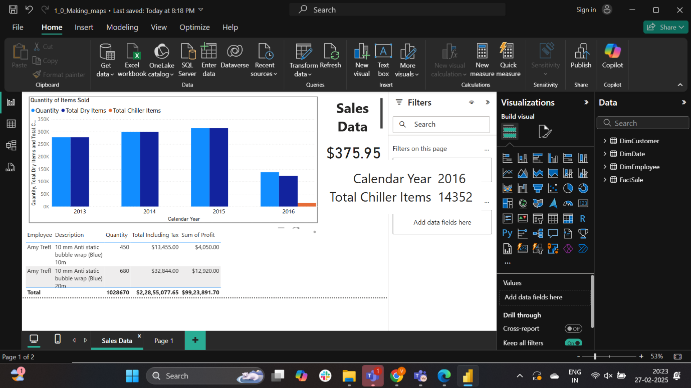

The total Chiller Items sold in the year 2016 are **14352.**

Part-2:

The data is loaded.

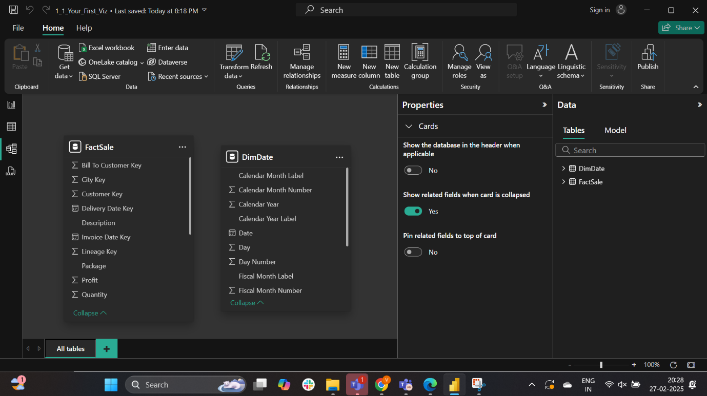

A relationship is created

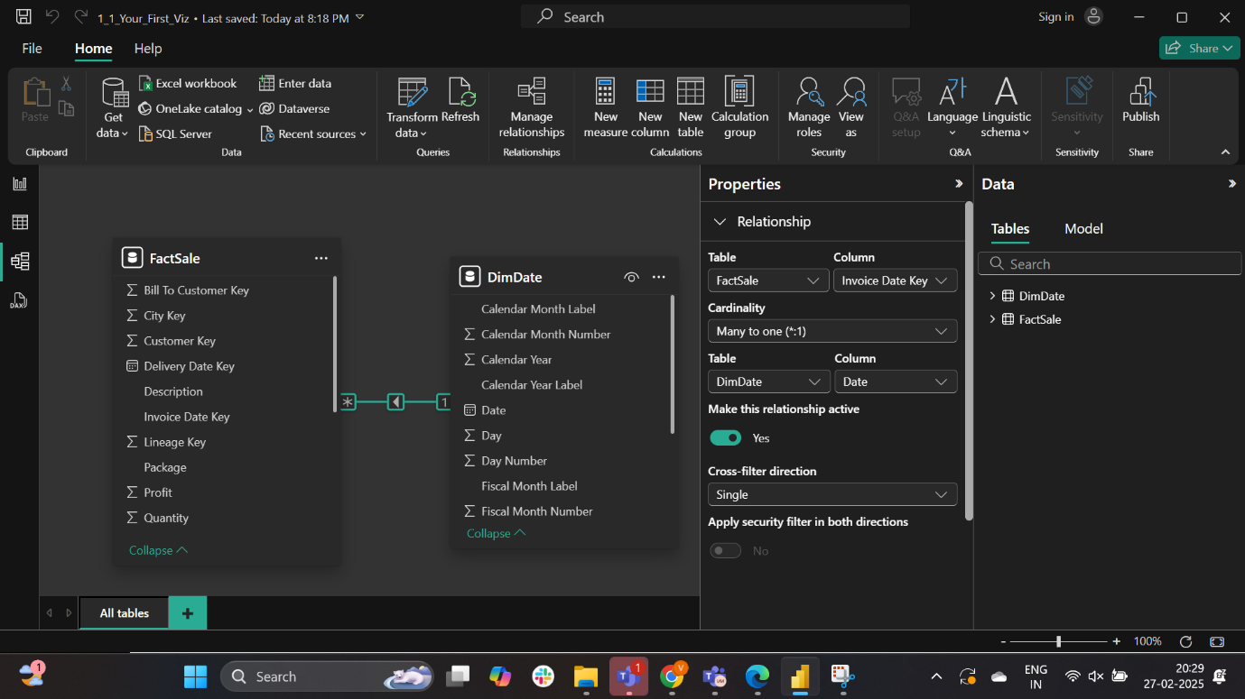

The visual is created

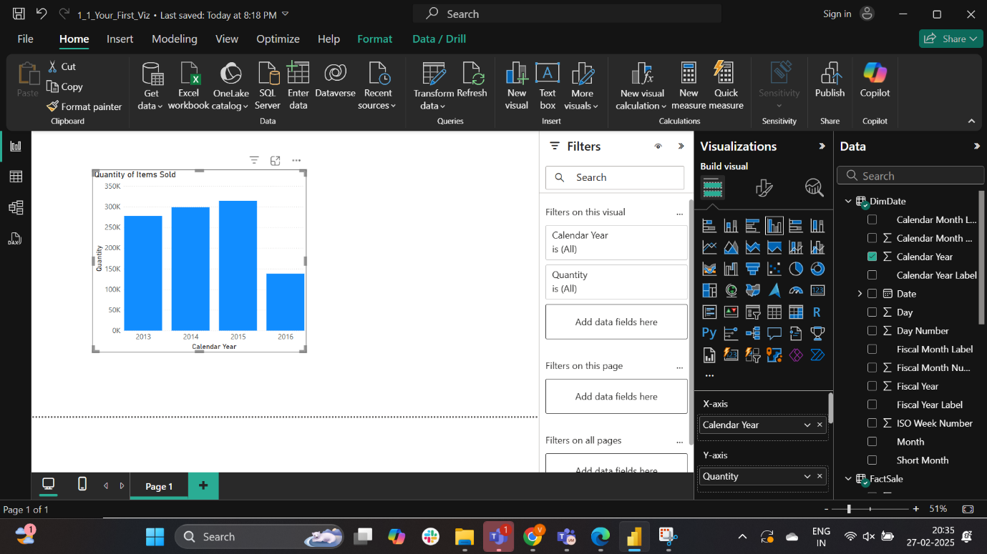

From the visualization bar graph the option 3 is correct

The quantity of items sold per year has only increased from 2013 to 2015.

Lab2:

Part-1:

1. Load data with transform and opened the power query editor.

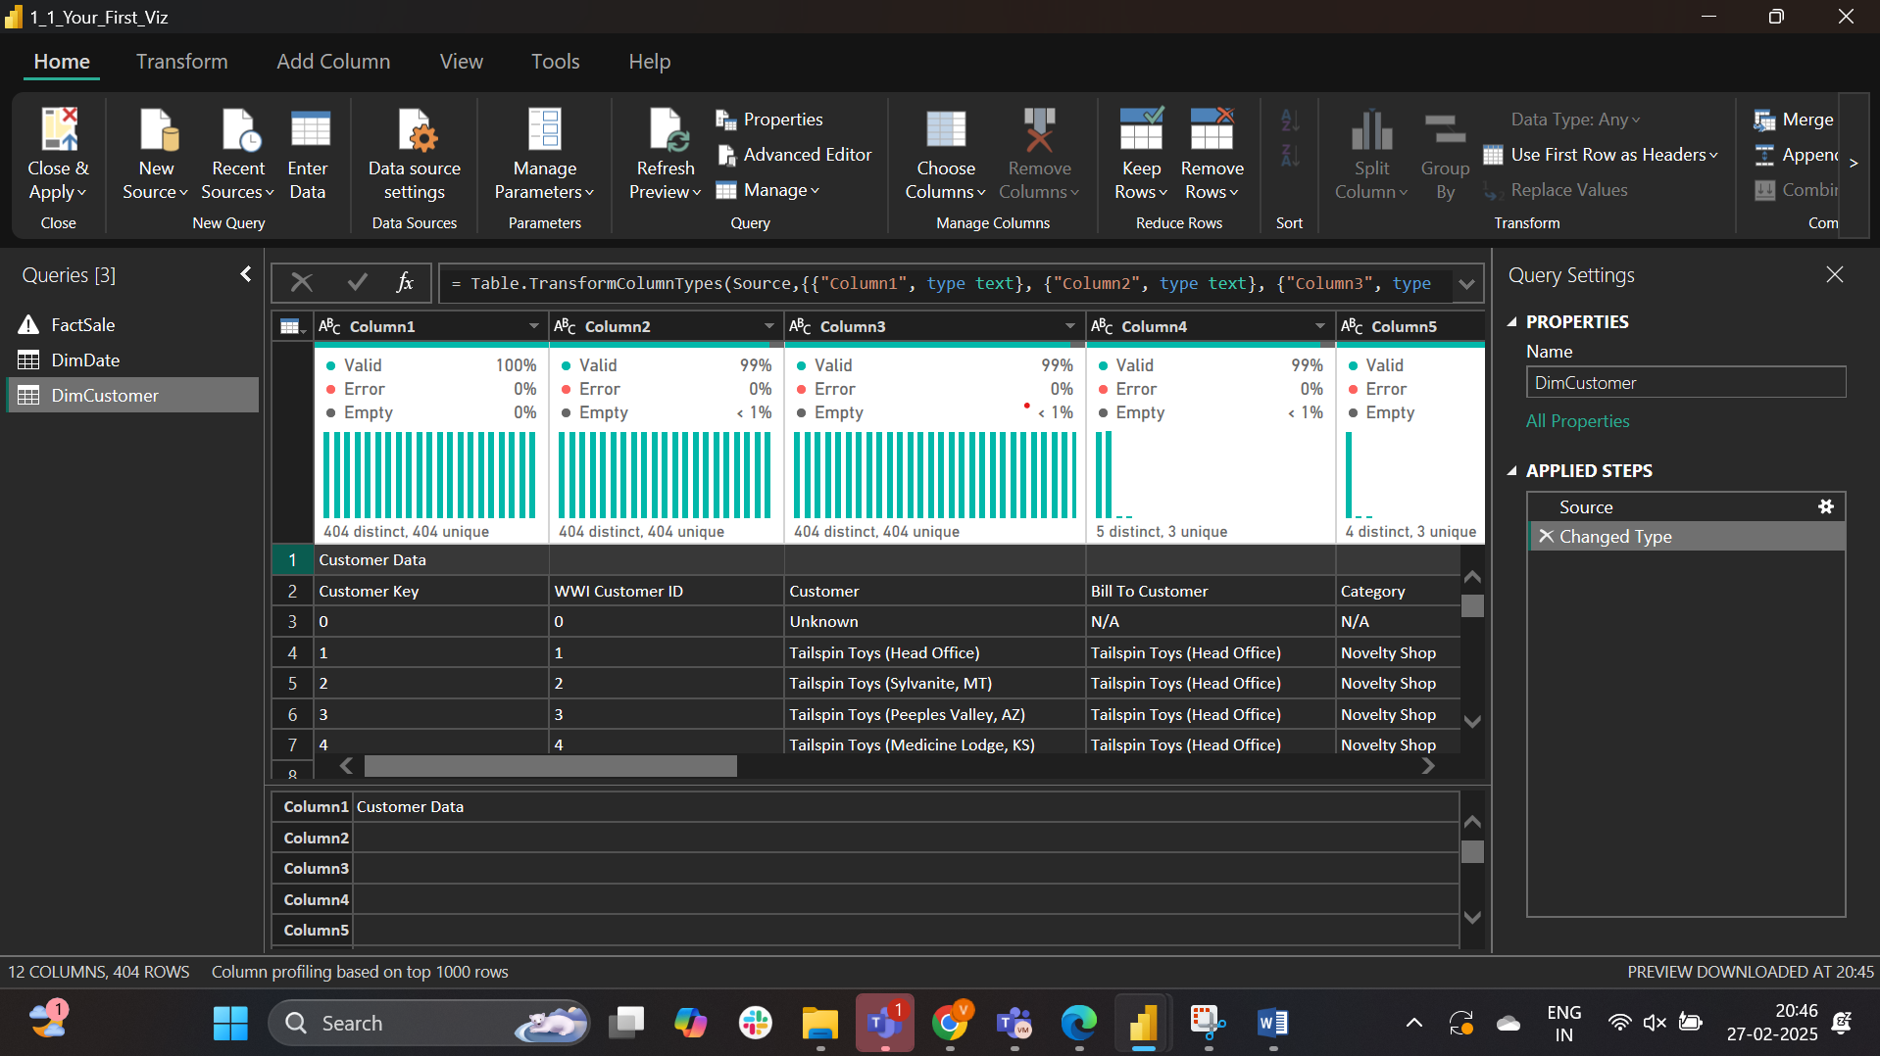

1. The first row is removed and the resulting row is made into the header row.

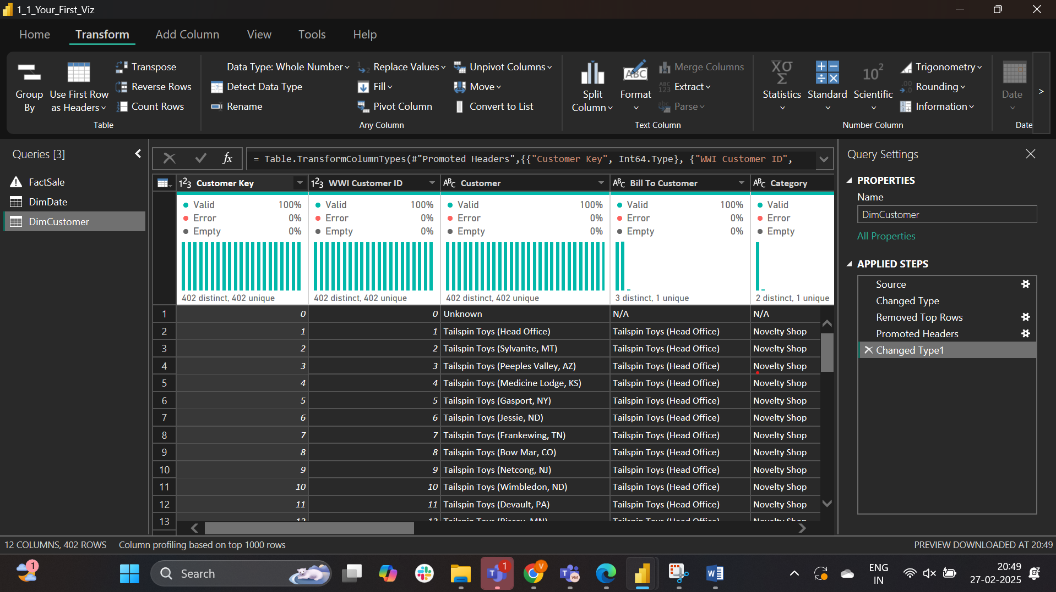

1. Valid_to and valid_from cloumns are removed.

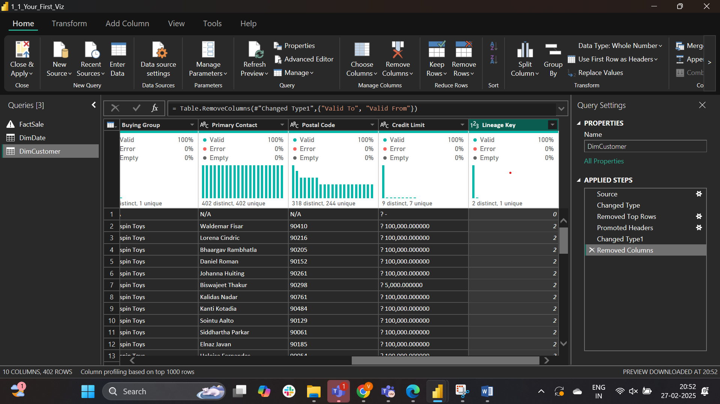

Ans: In the applied steps of power query editor there are 5 steps.

Part-2:

A relationship between the two tables is recognized.

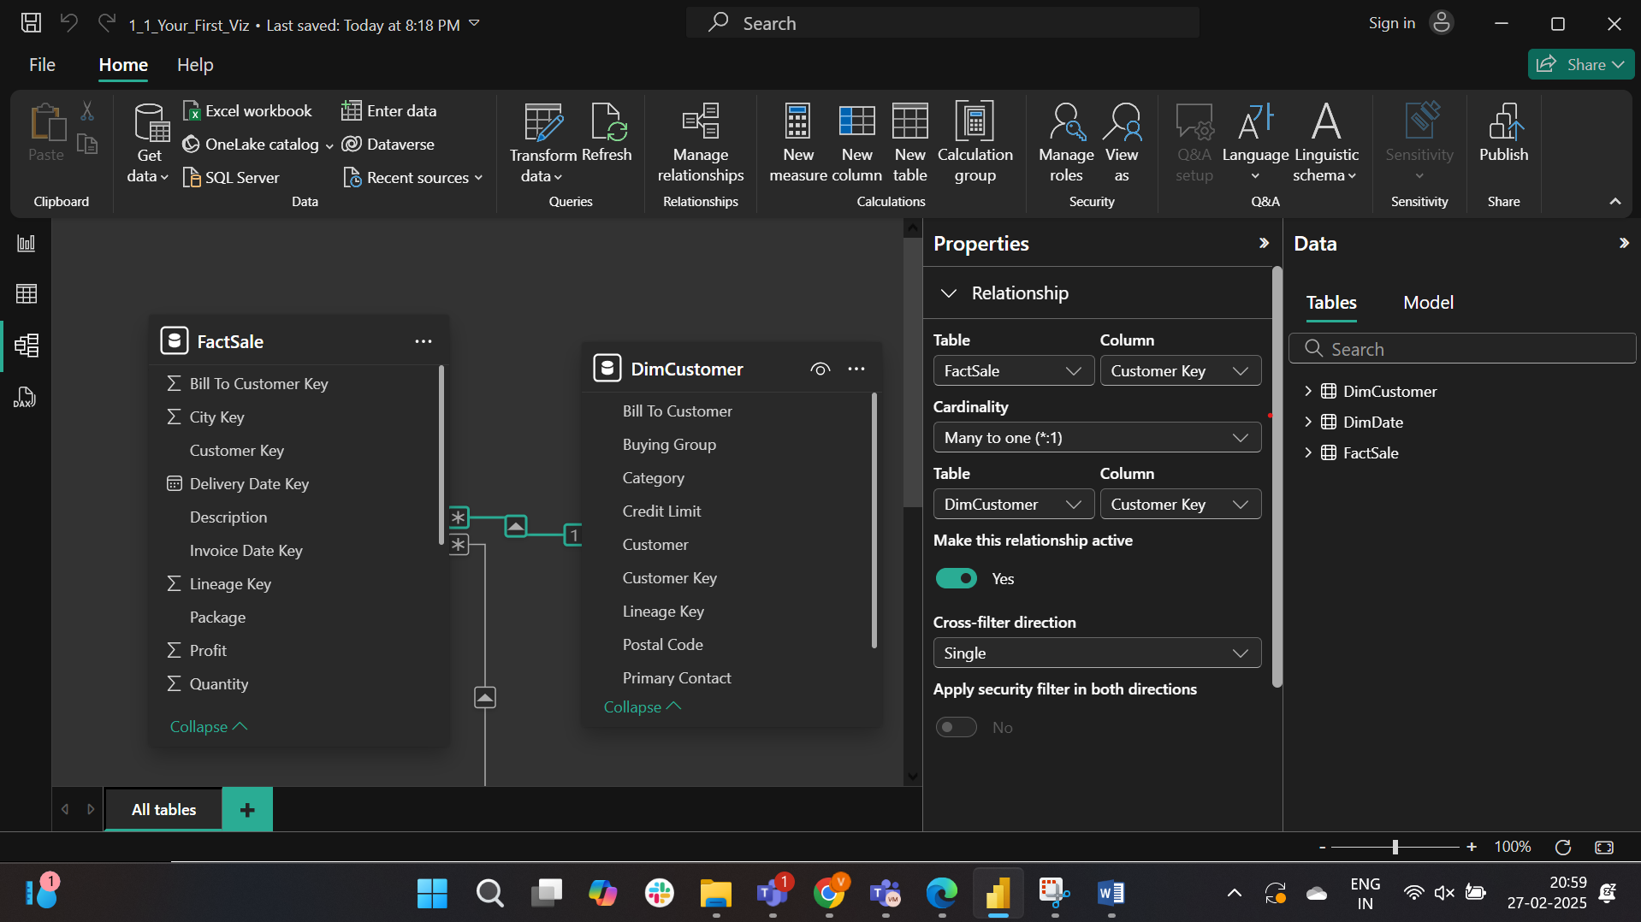

A clustered chart is created and changed the sum of total including Tax to minimum of total including Tax.

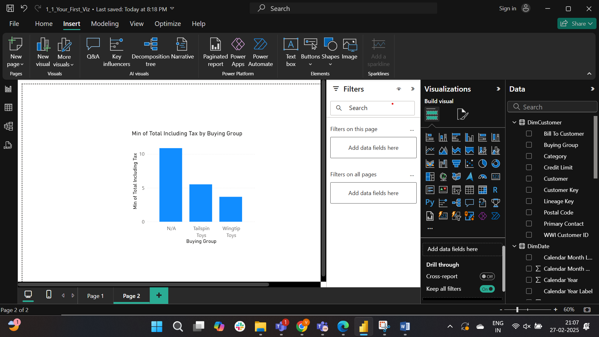

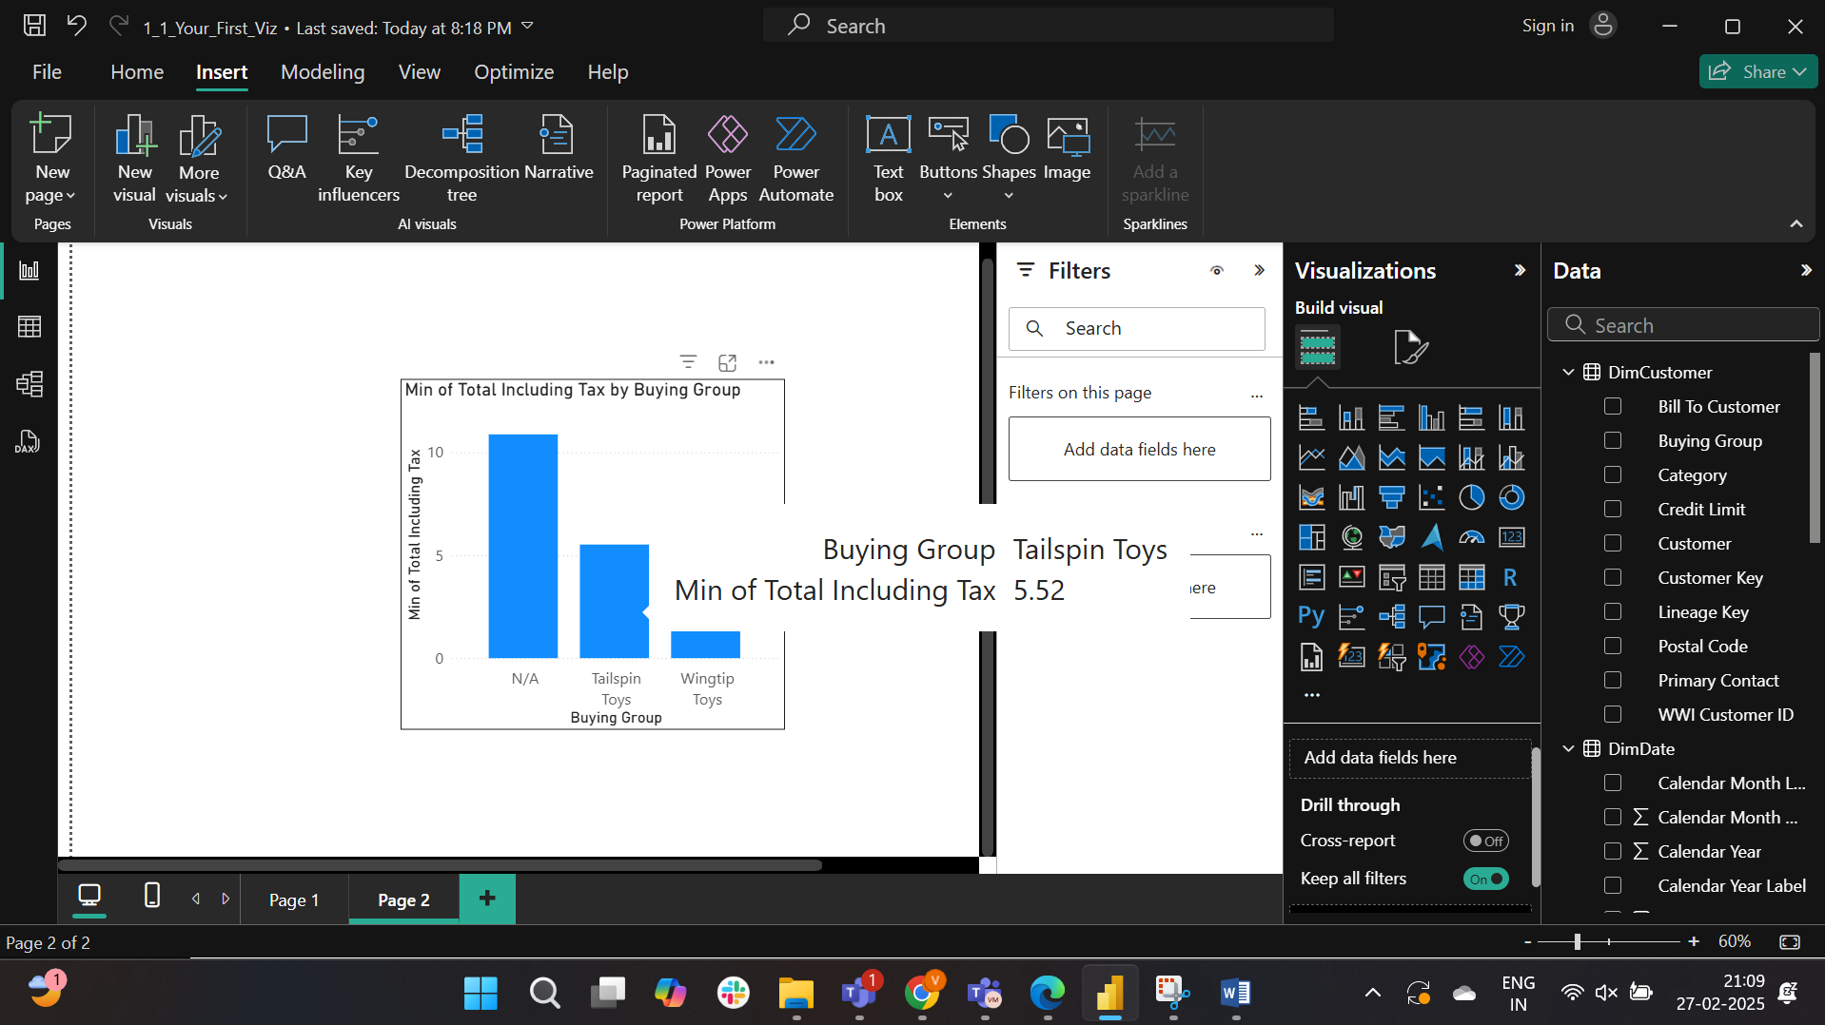

Answer is 5.5

Part-3

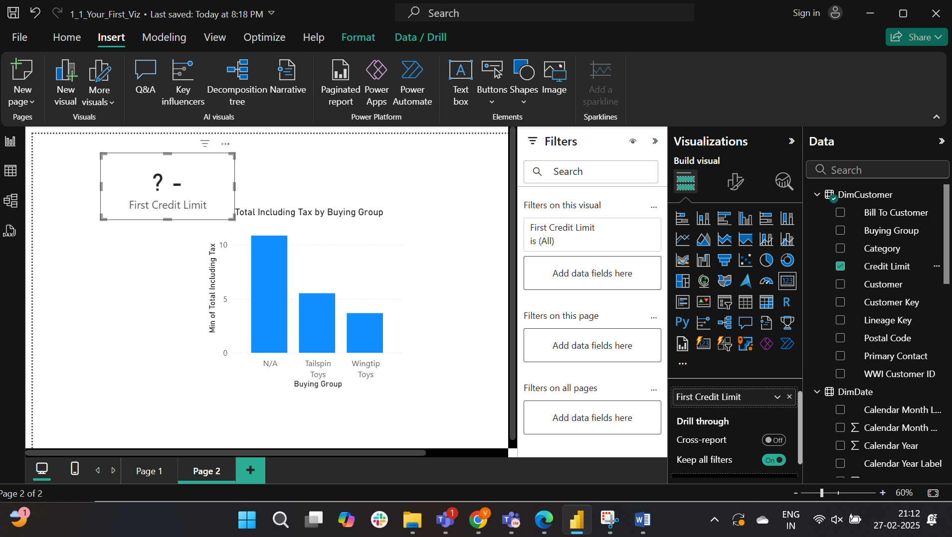

Opened the power query editor to replace the credit limit values 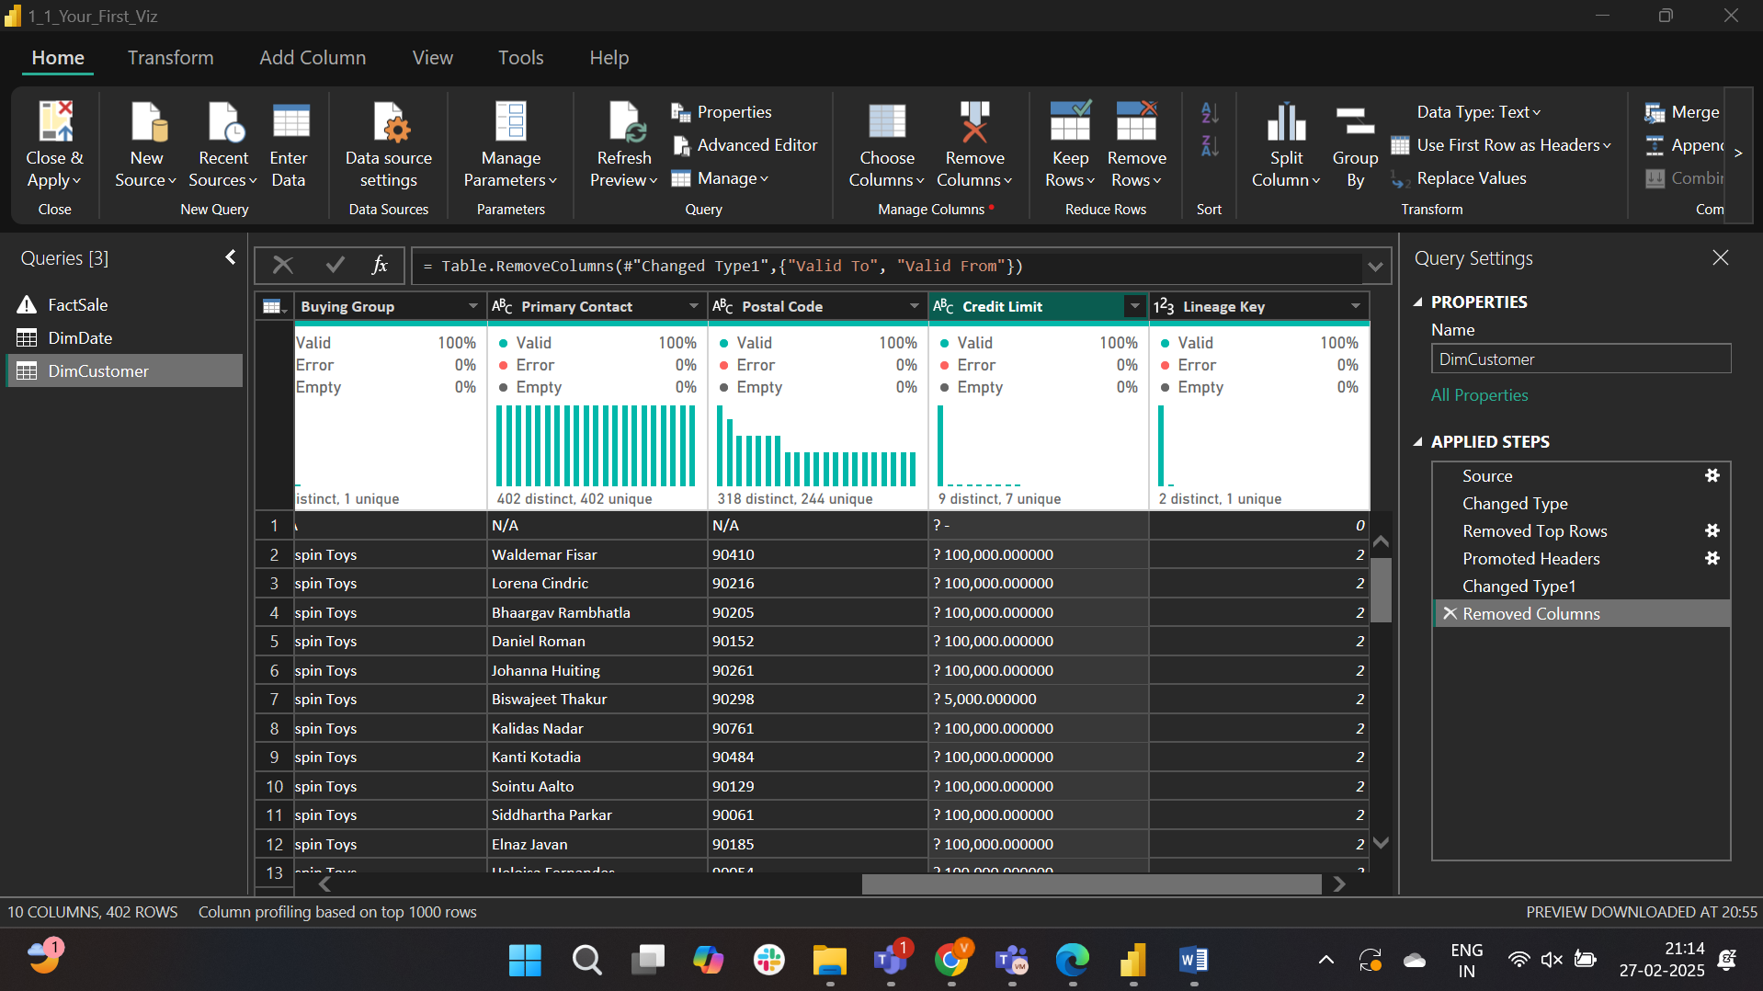

Replacing ‘?’ with a blank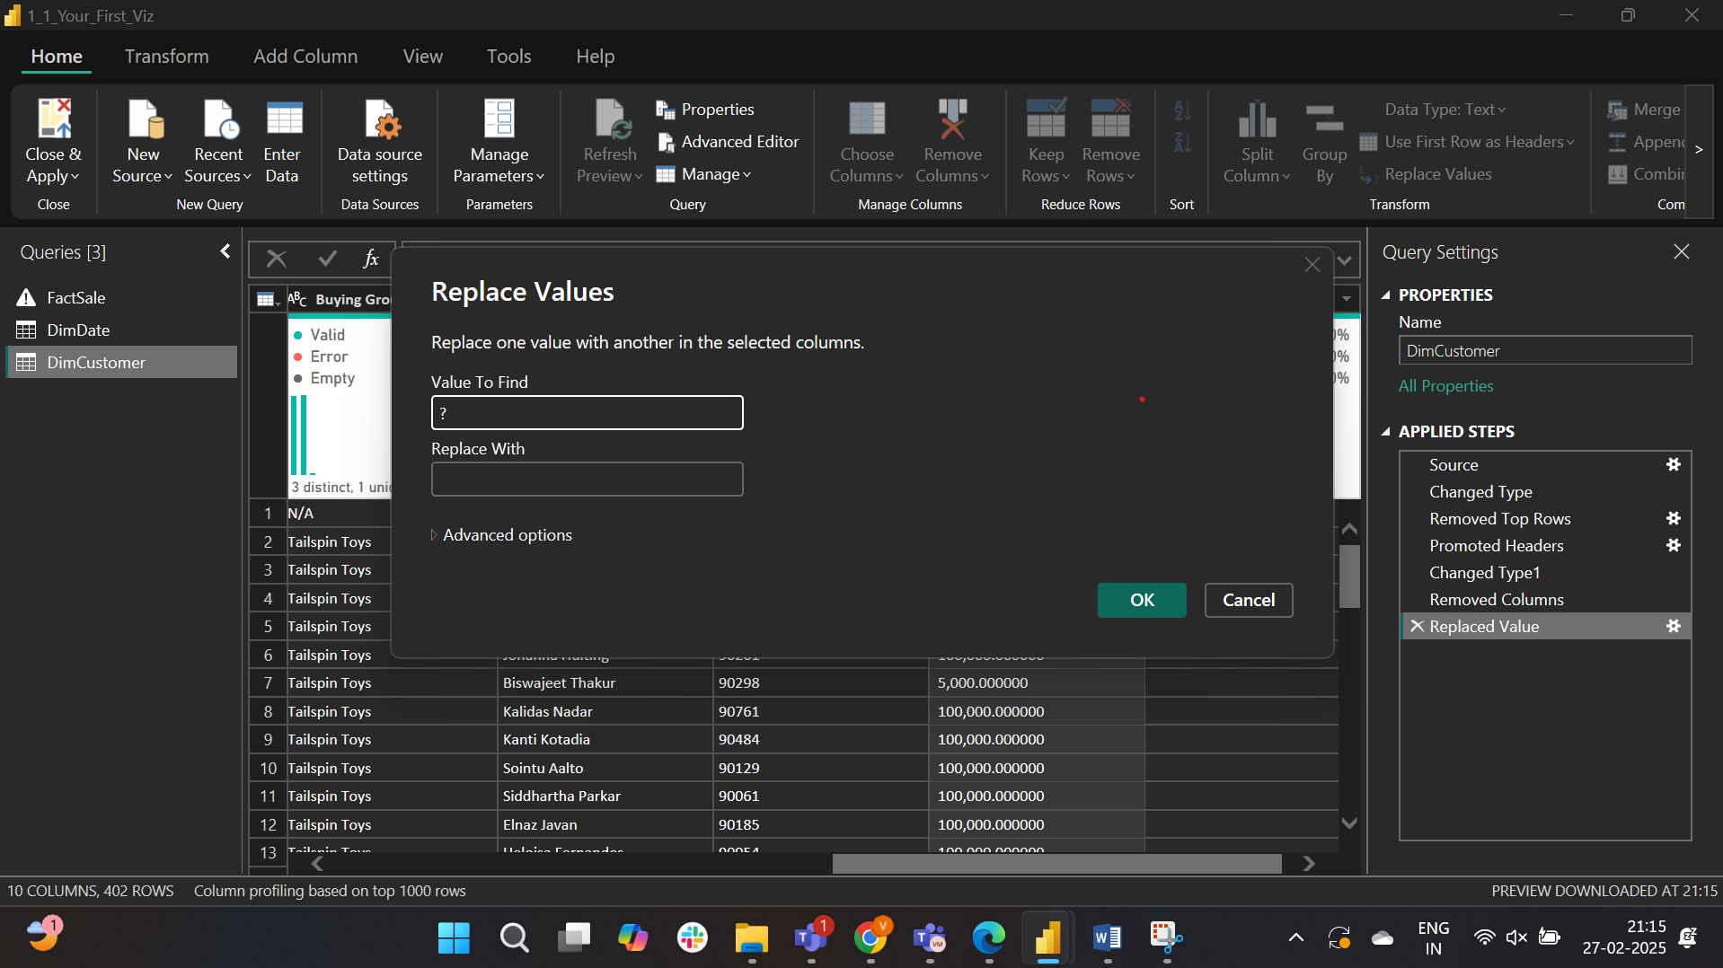

Replacing ‘-‘ with a blank

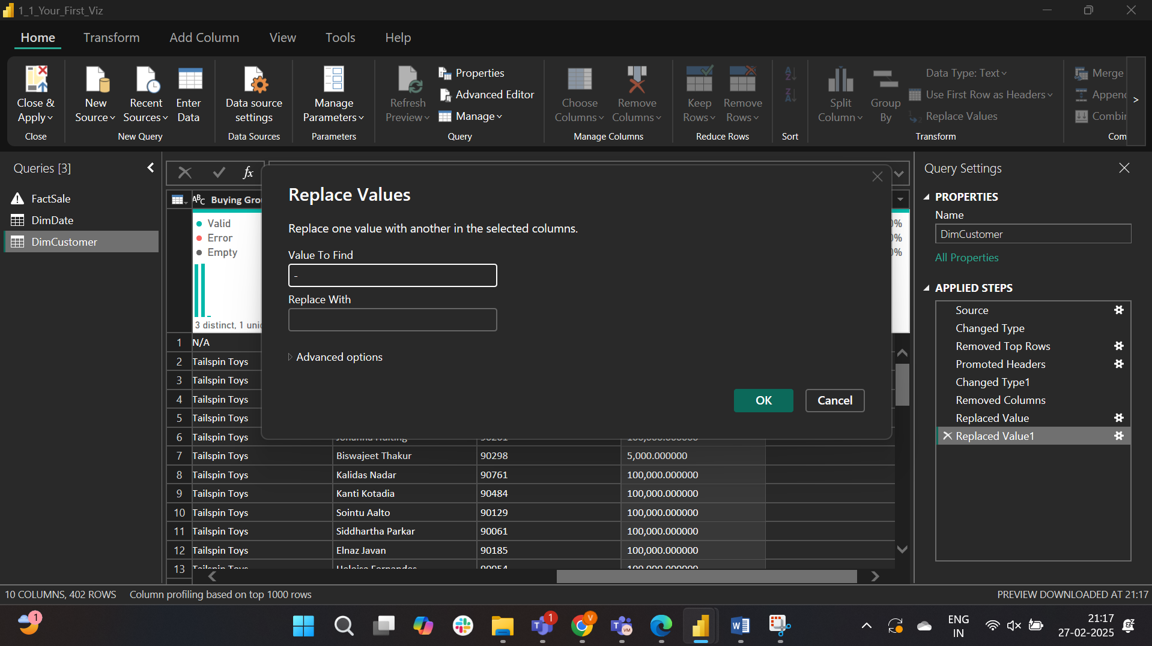

Changing the datatype

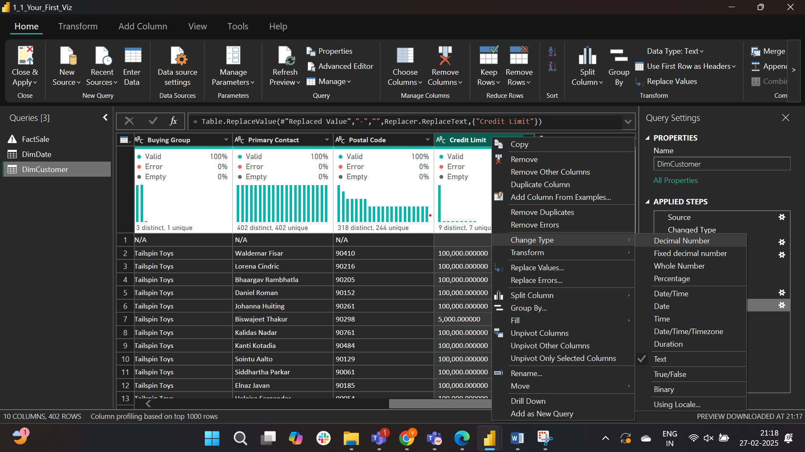

Changed the card value to average credit limit.

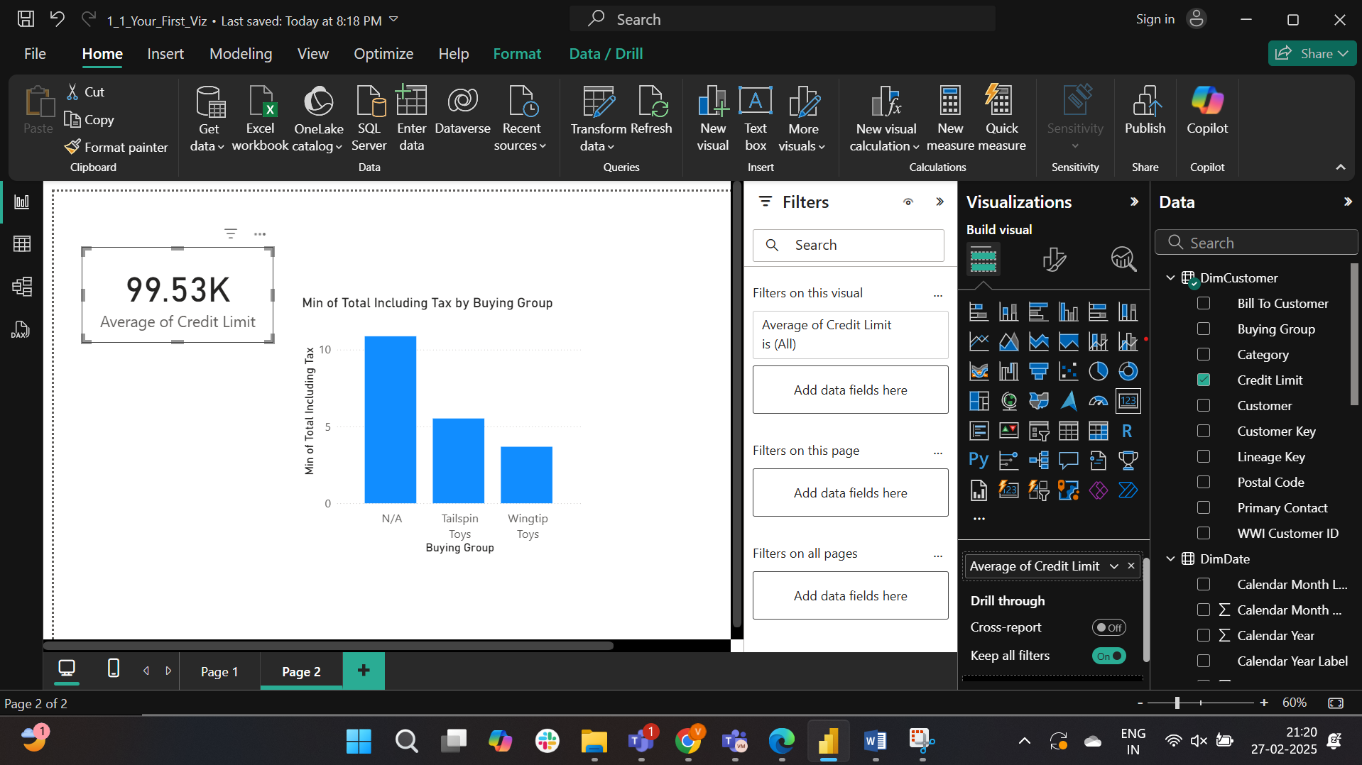

The answer is $99.53K

Part4:

Data view of factsale

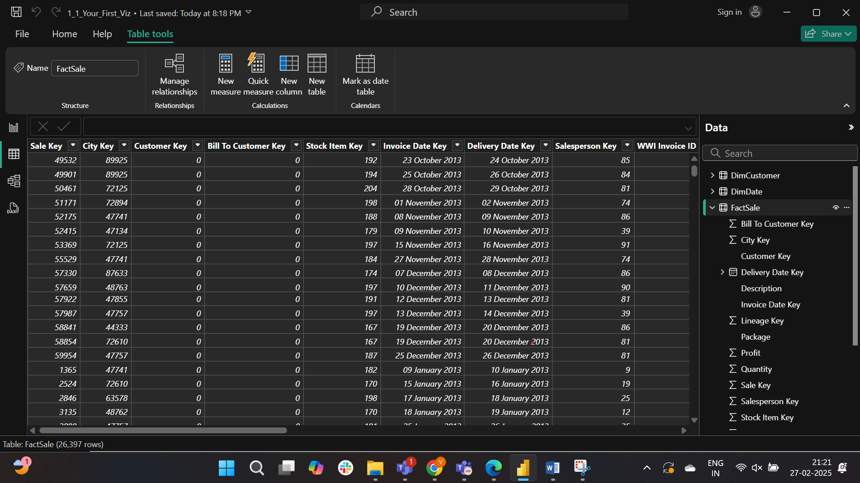

The column type of total including tax is changed into currency, the decimal place is changed from auto to 2. 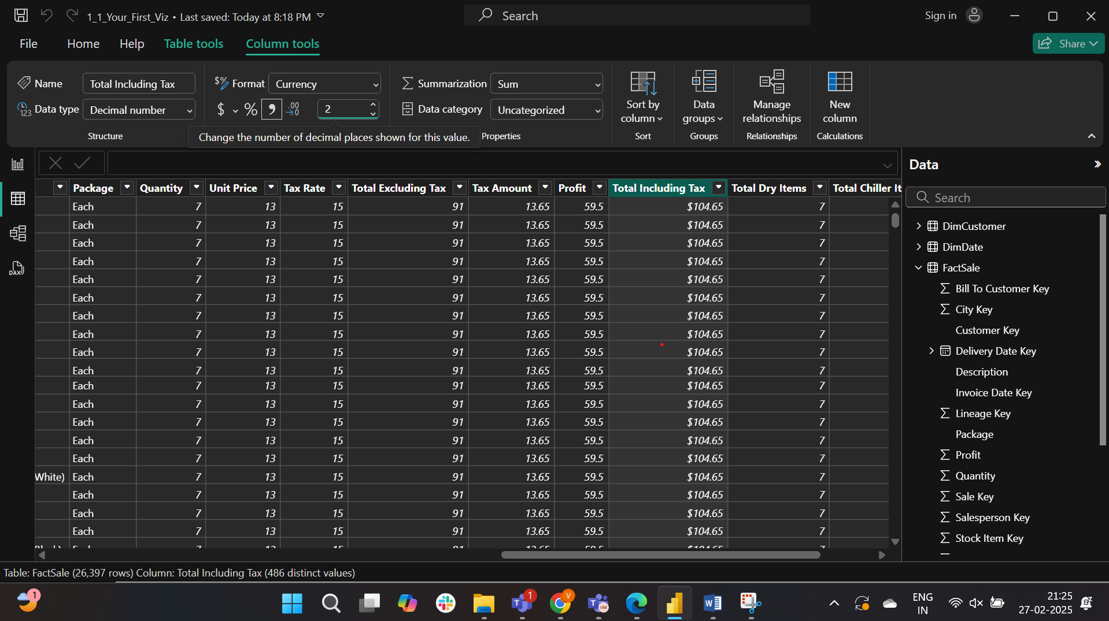

The aggregation is changed from sum to average.

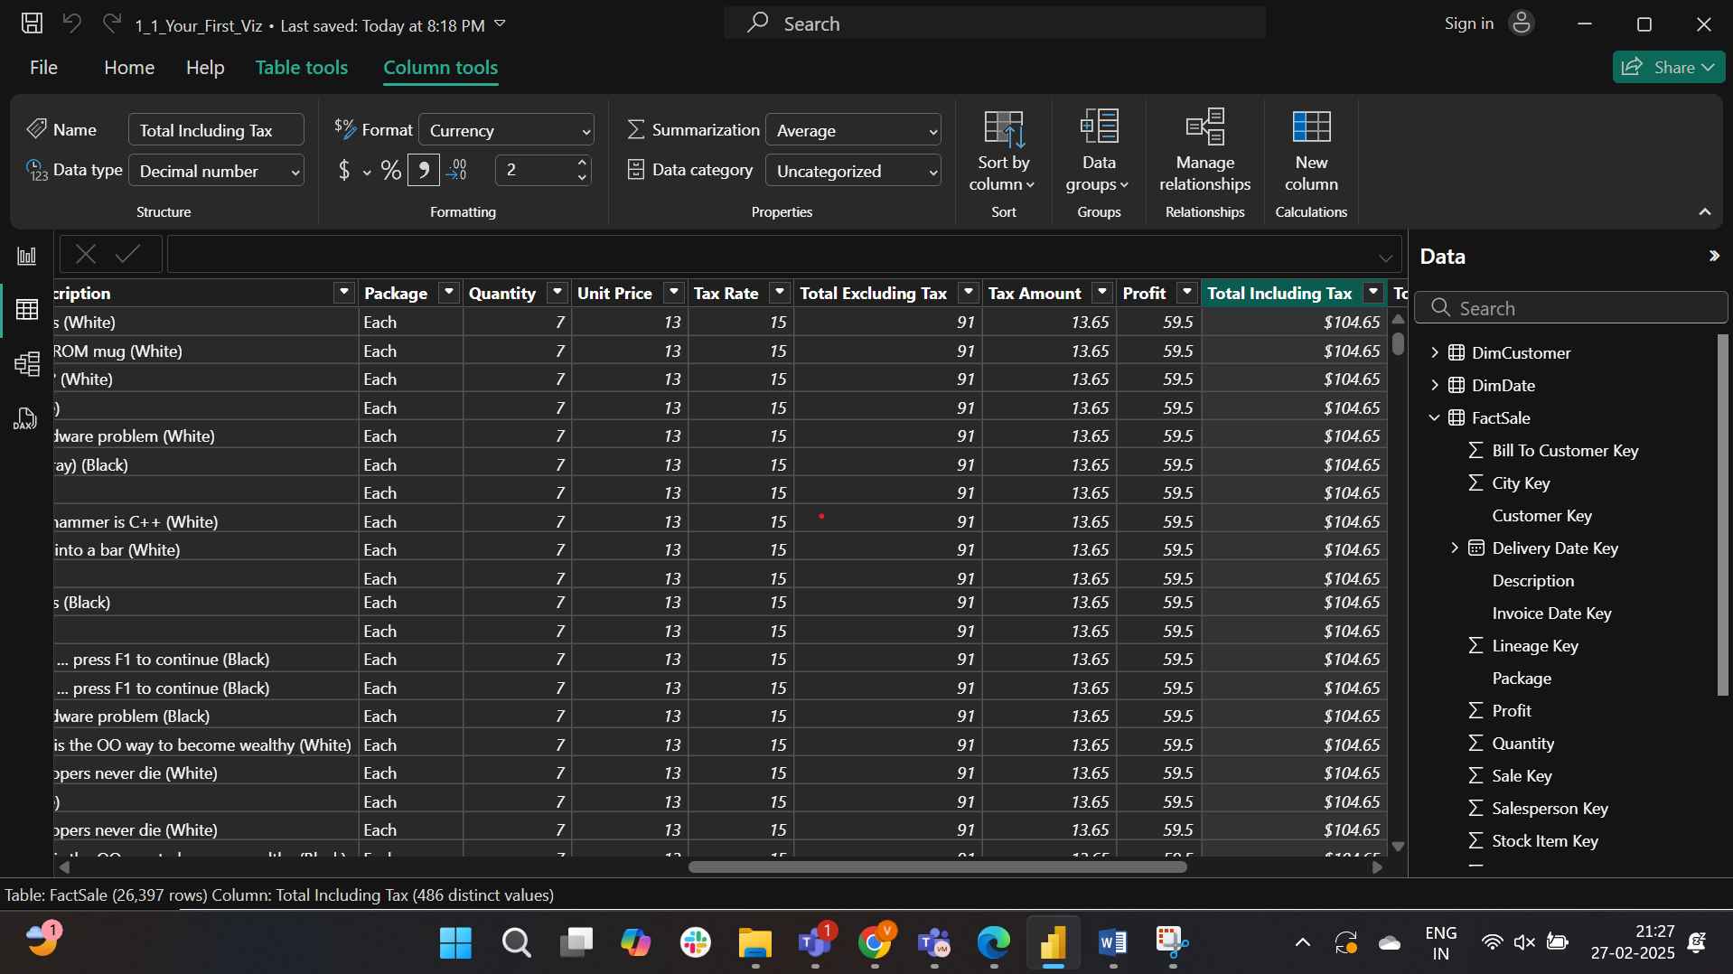

The same done to the profit column type change to currency and decimal place of 2.

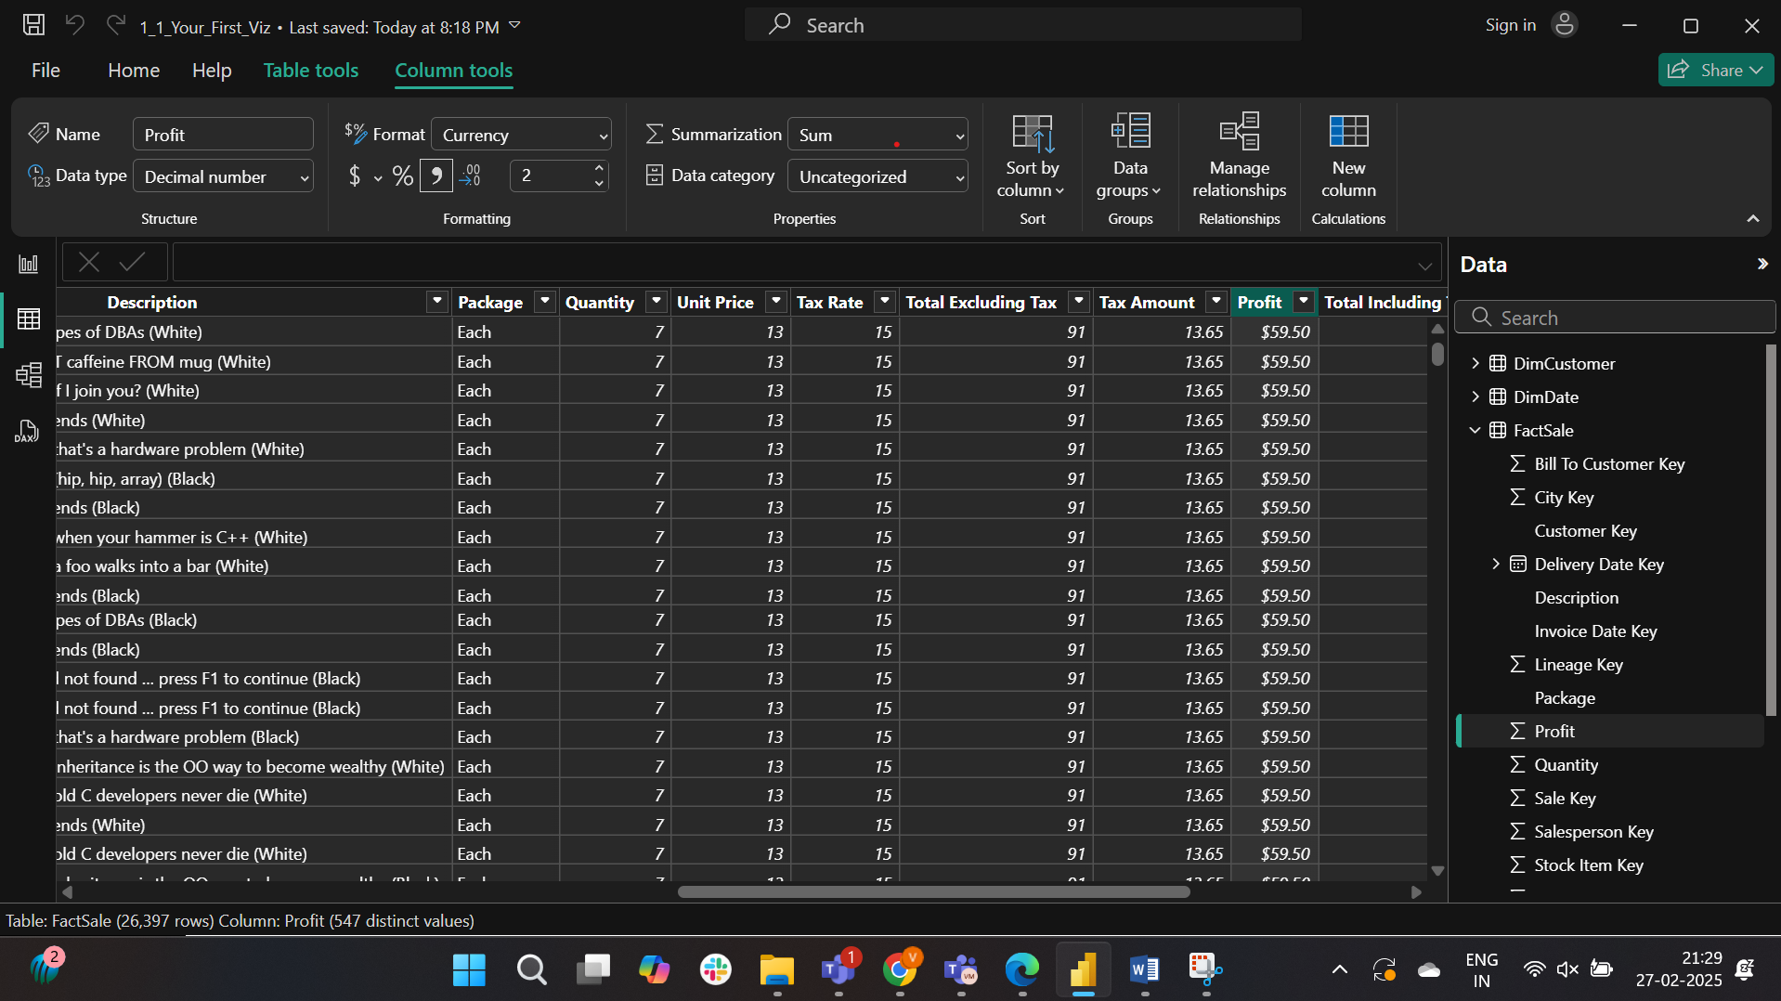

The card is added in the report for total including tax.

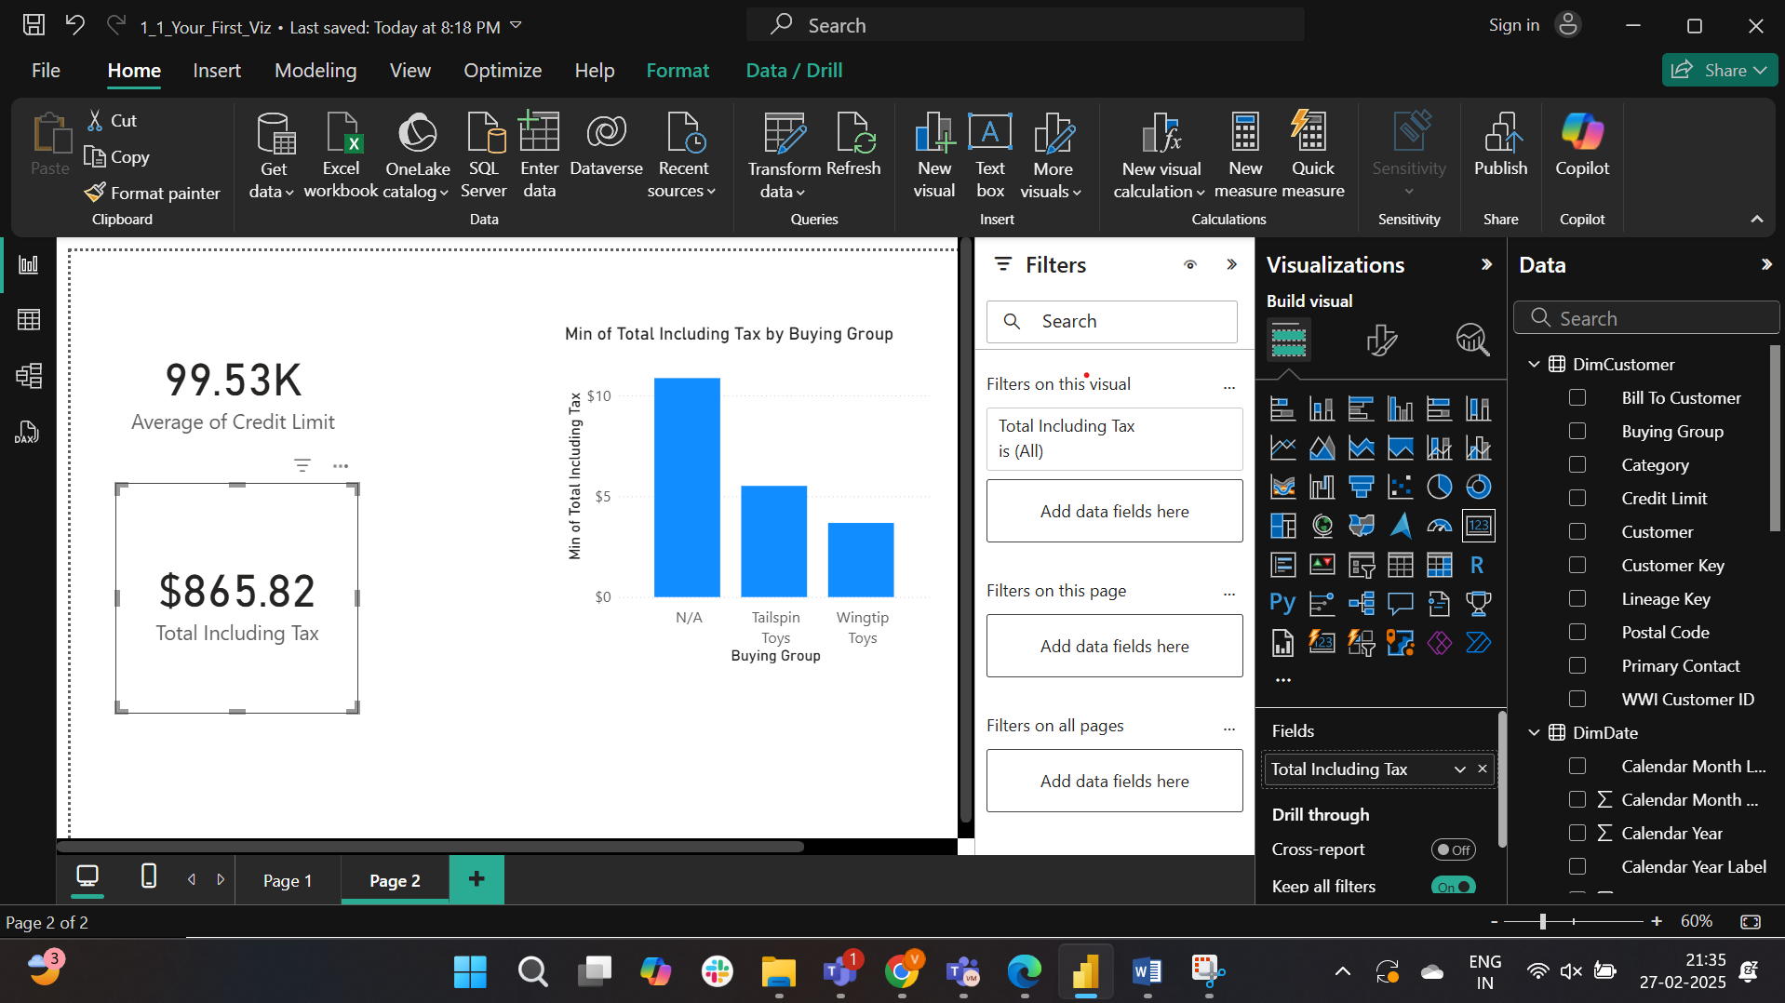

The answer is $865.82

Part 5:

The DimCity table is loaded

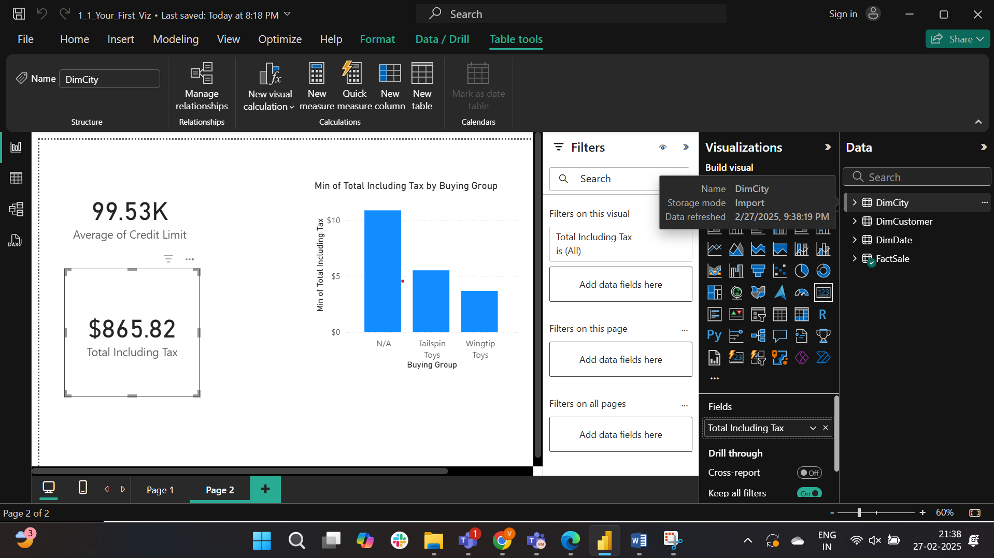

There exists a relationship between the dimCity and factsale

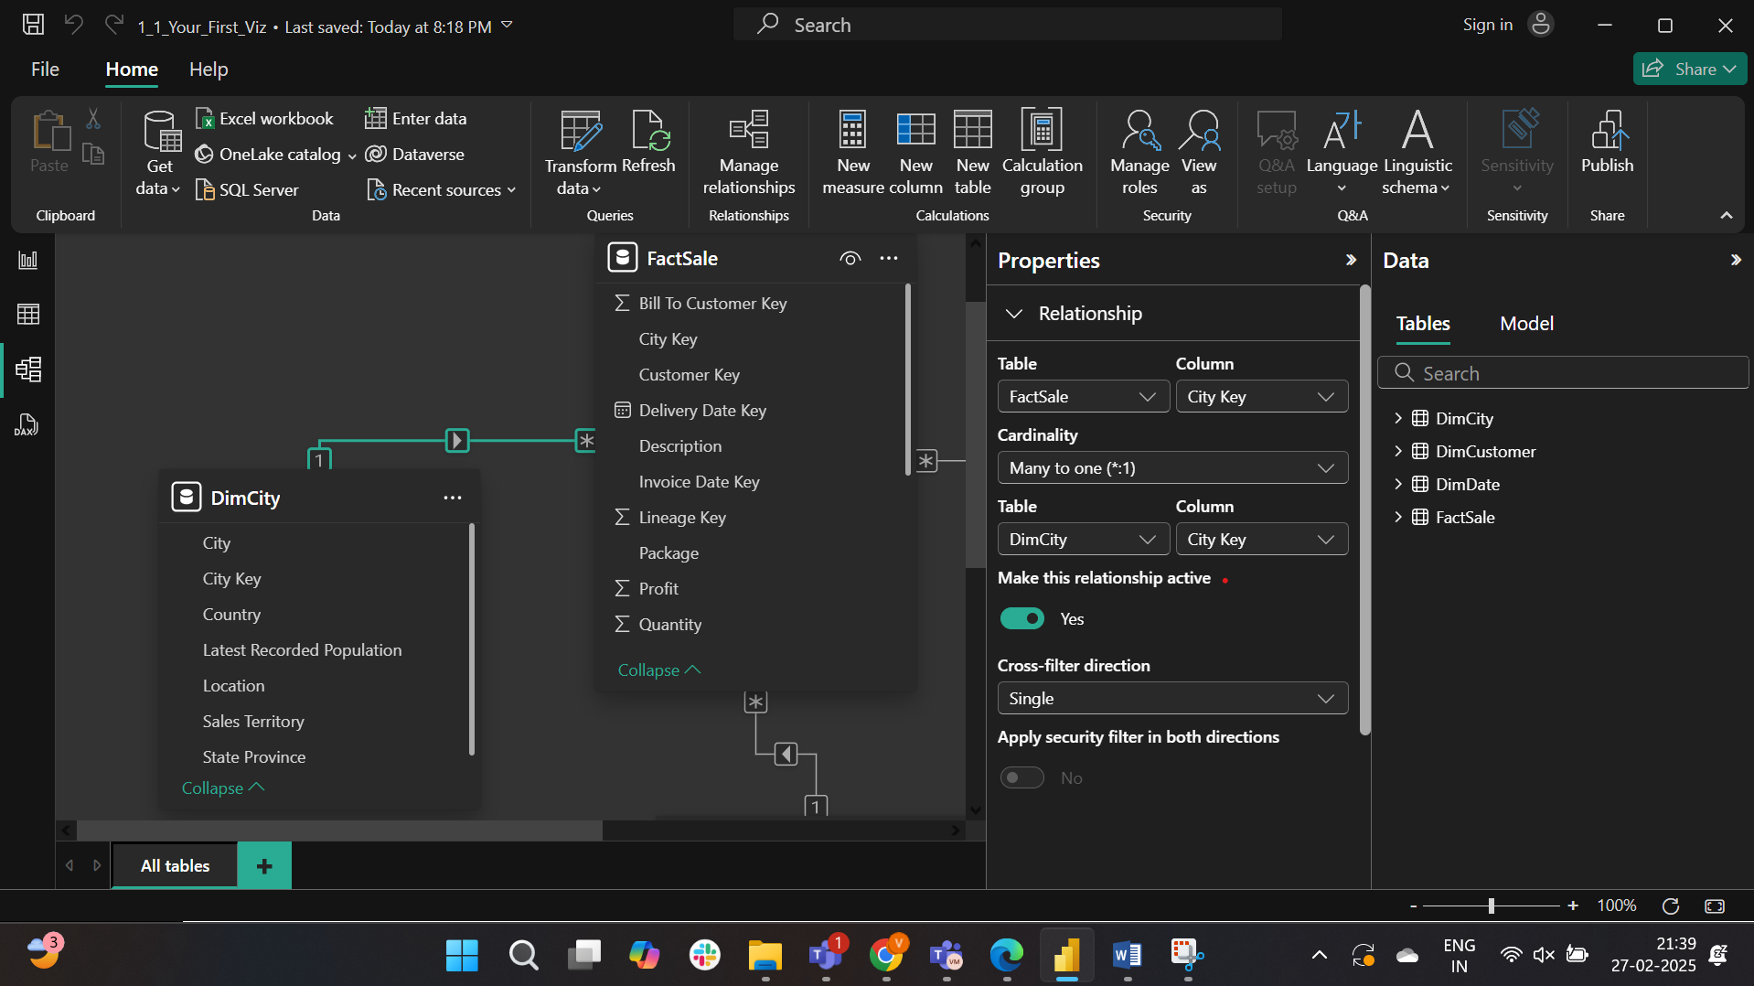

The category is changed to State or Province

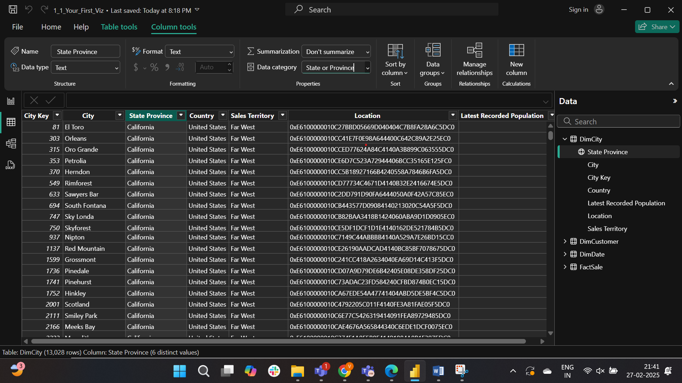

The aggregation of profit is average in FactSale

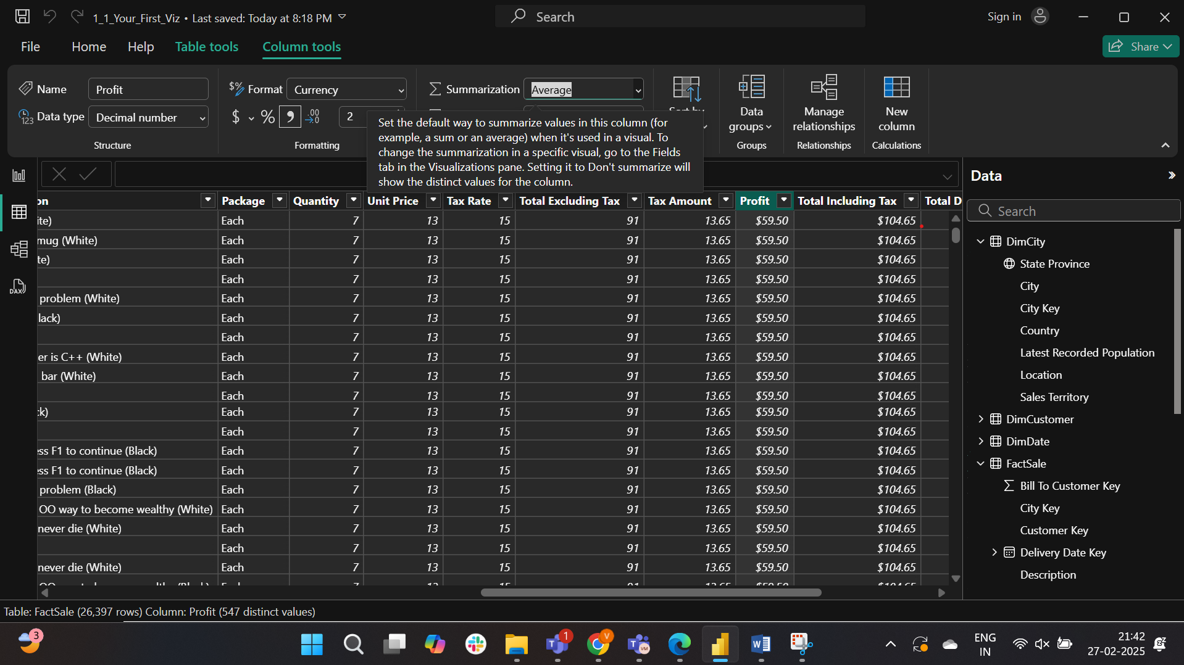

A map is created 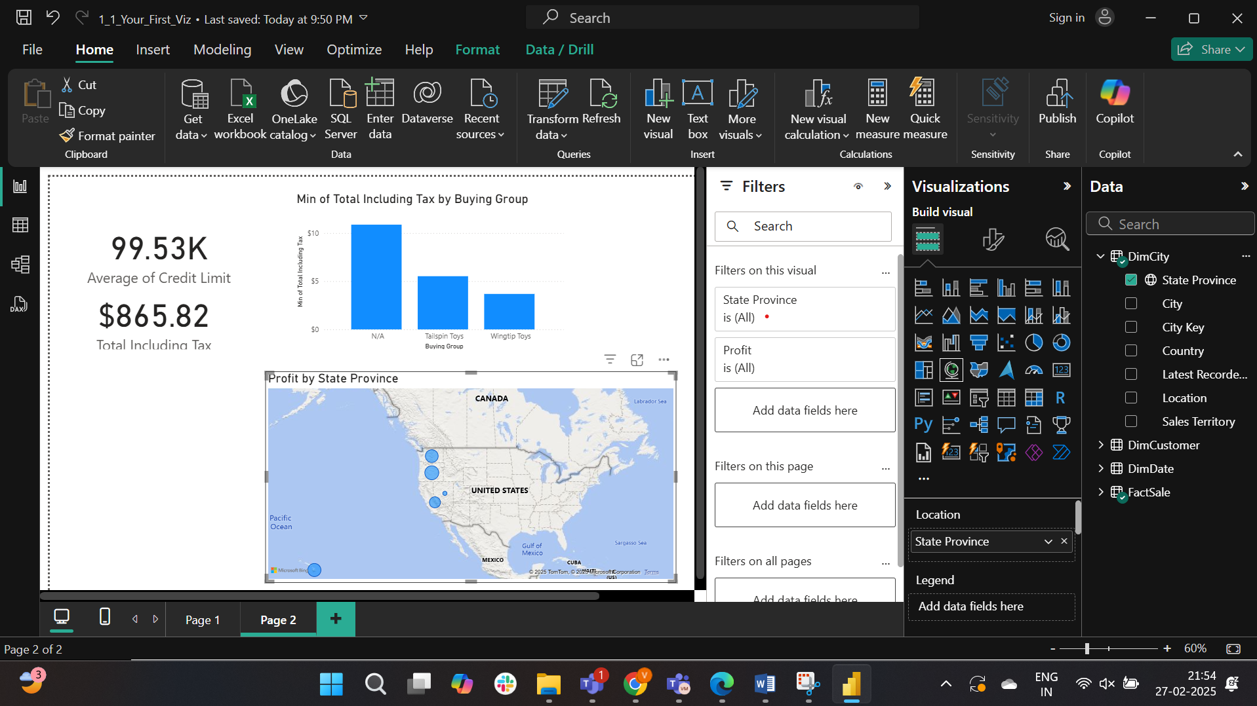

Slicer is created for buying group from DimCustomer

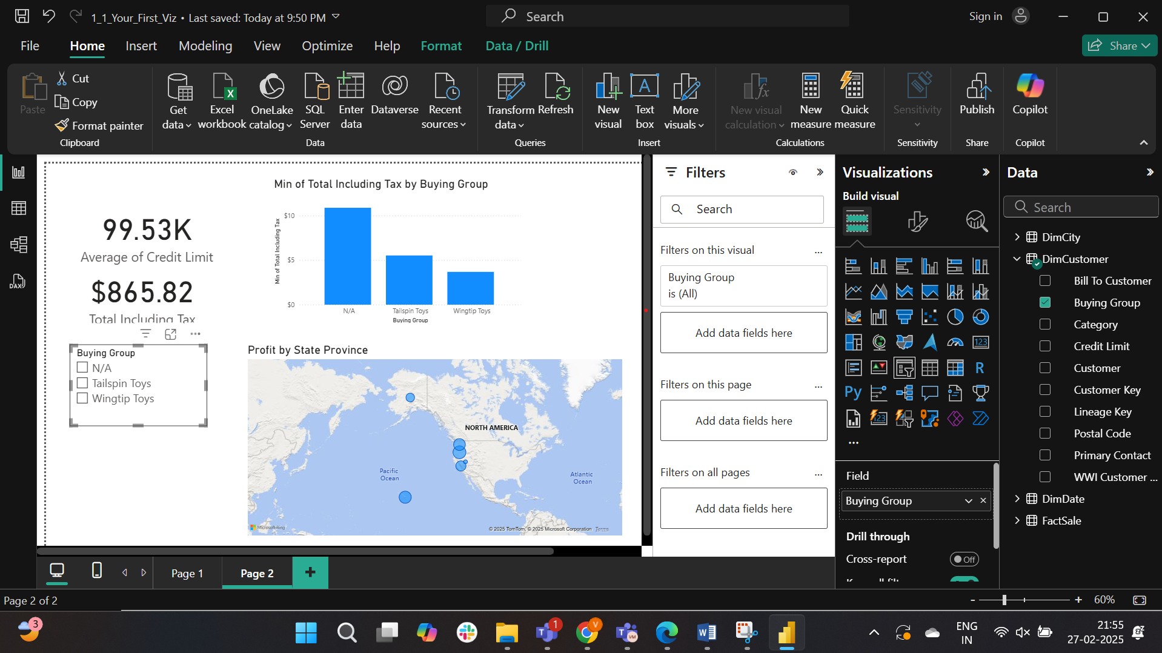

The report is arranged and a title is added.

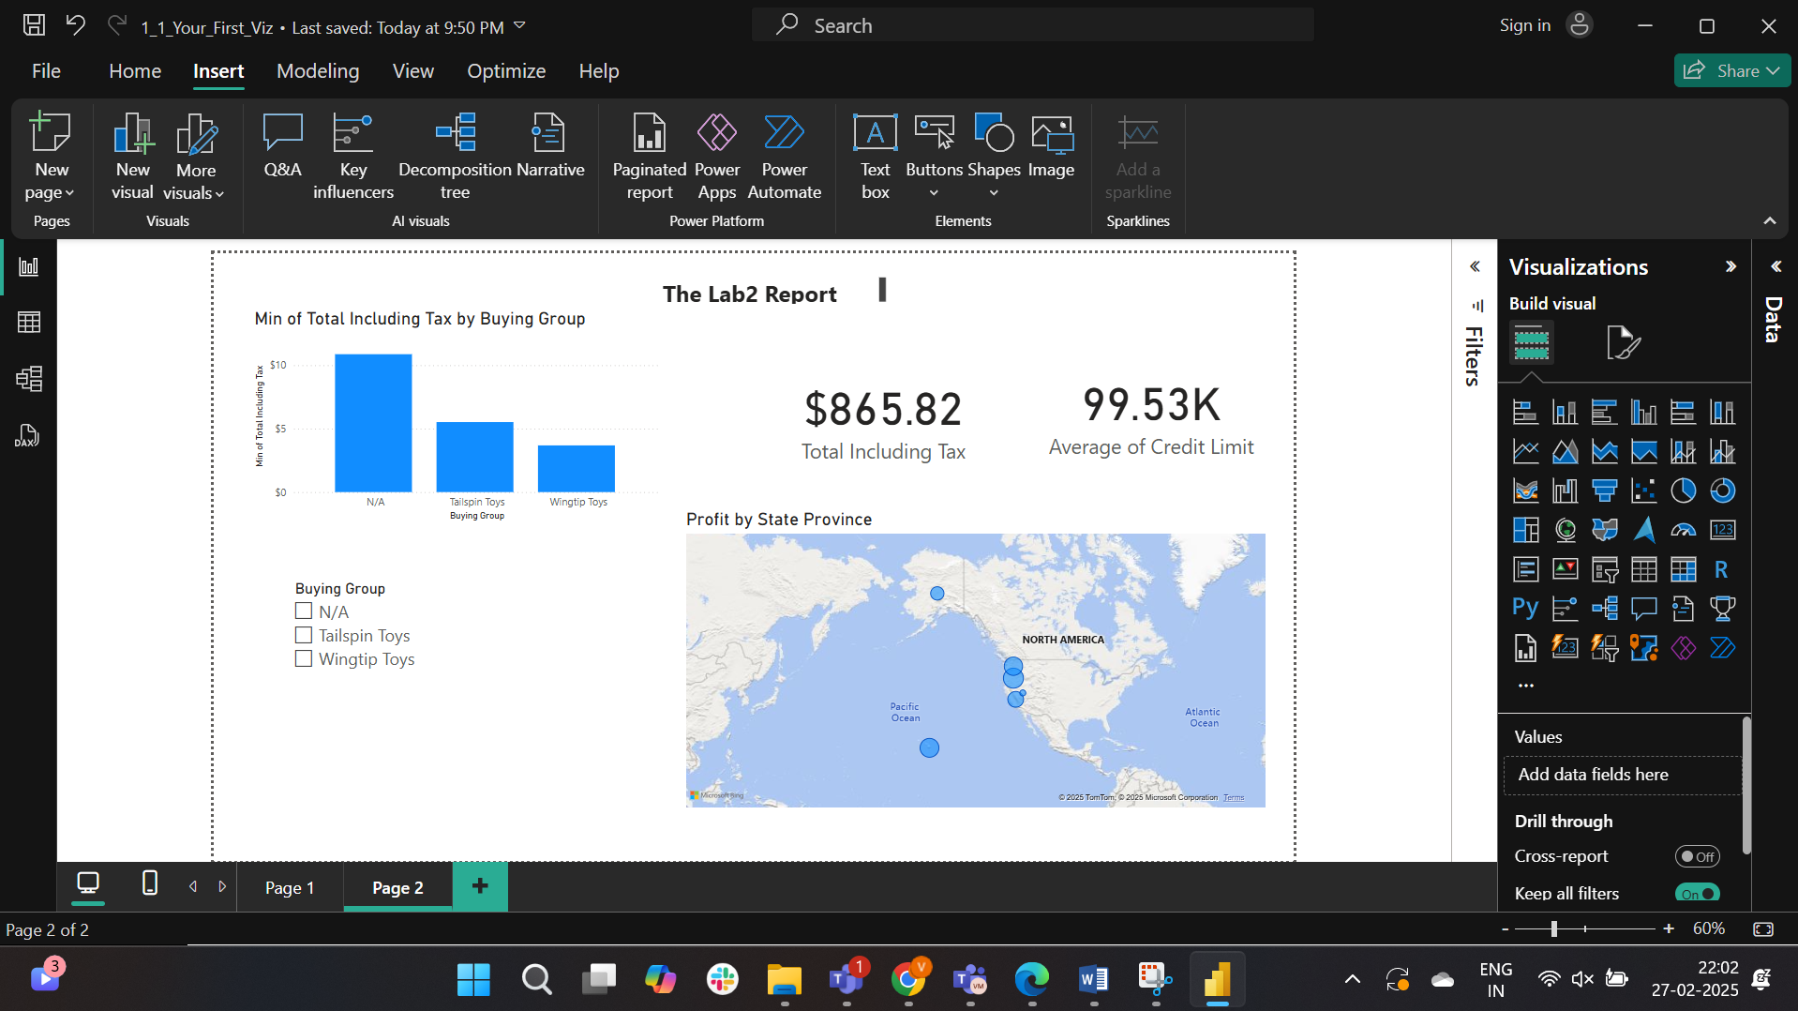

Washington provides highest average profit forWingtip Toys.

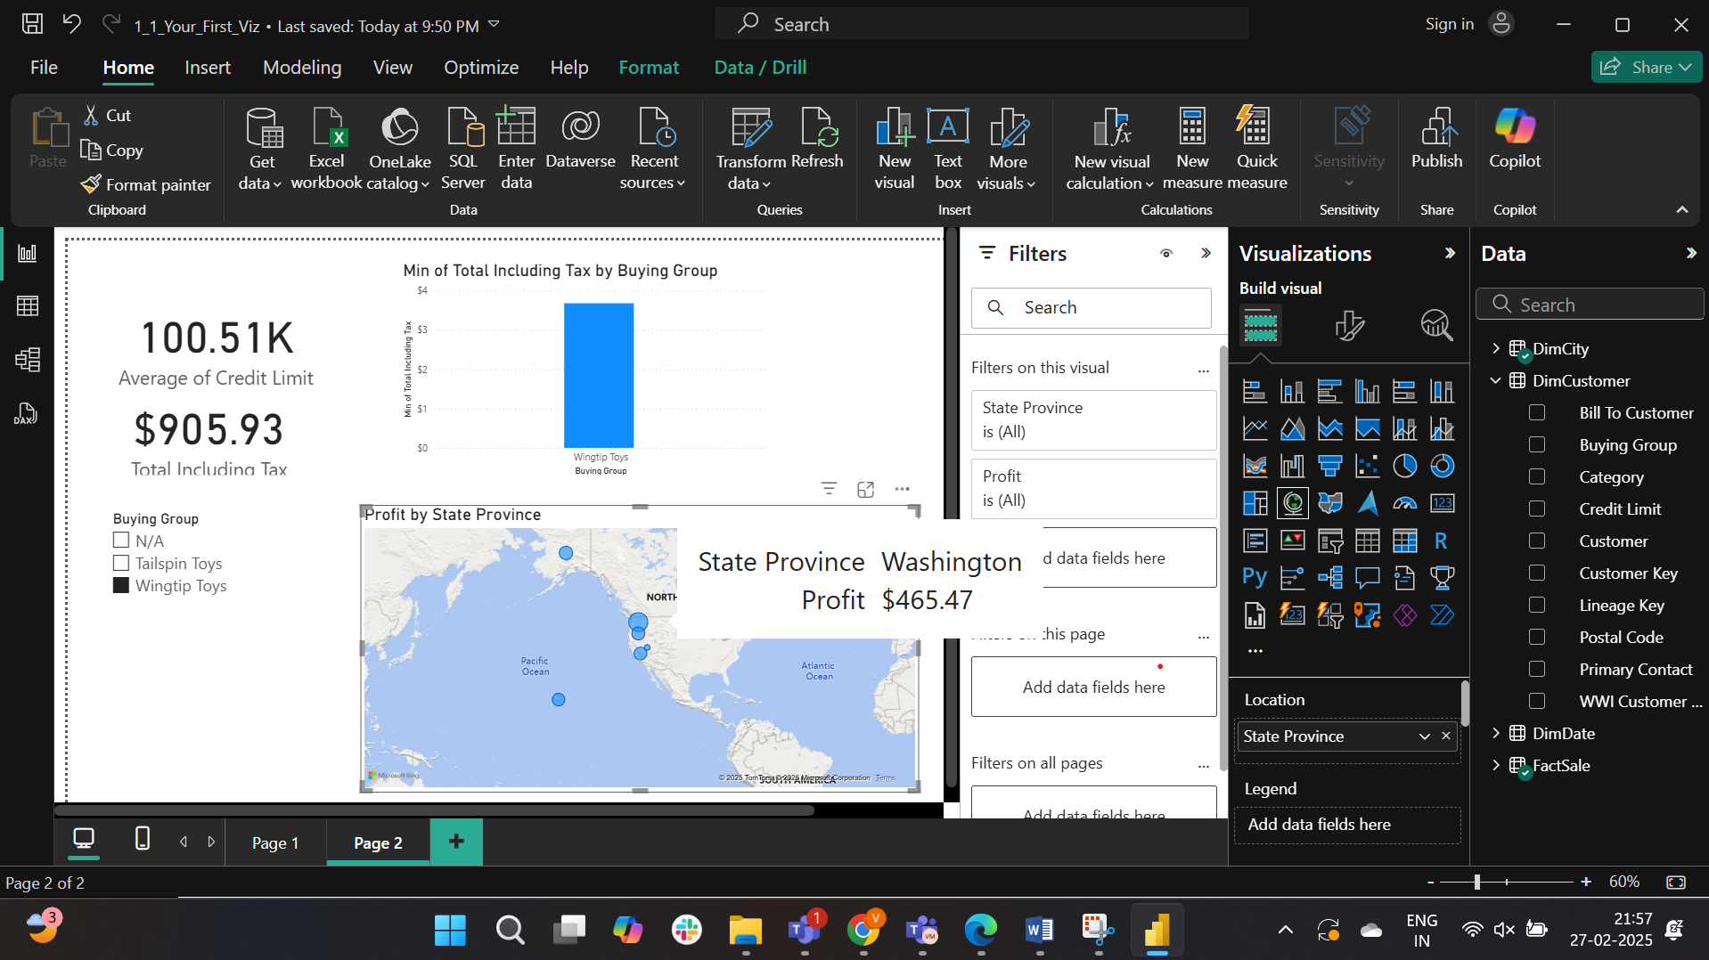

Lab3:

Opened the file

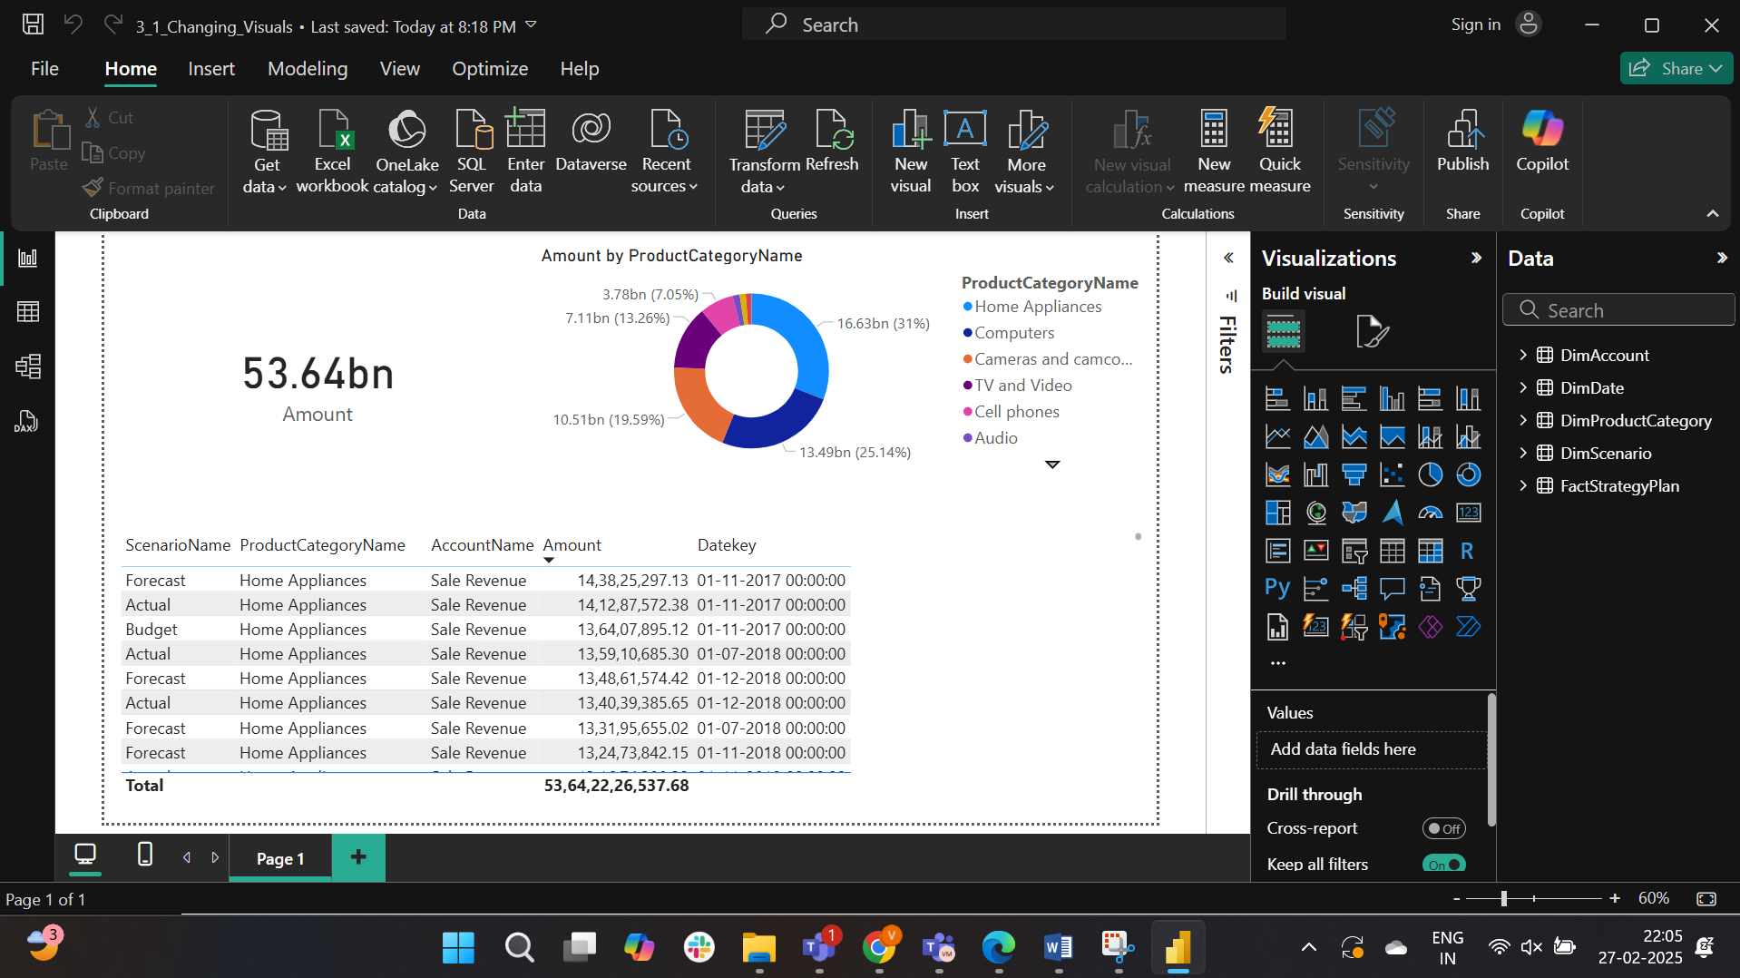

The donut chart is changed to treemap

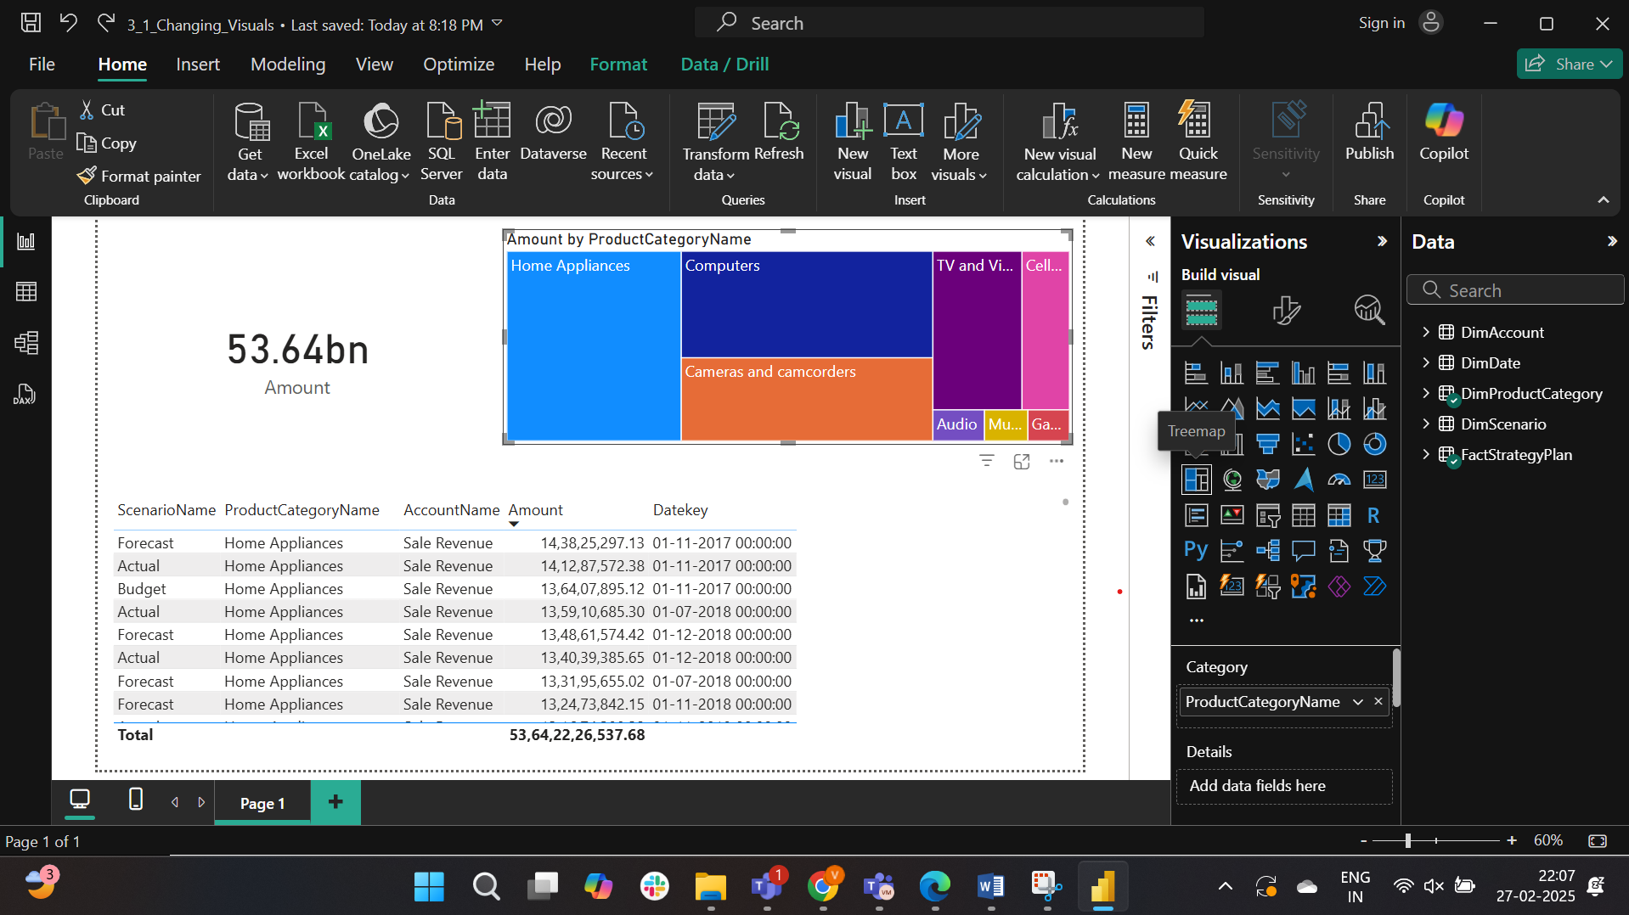

The title is changed and formatted.

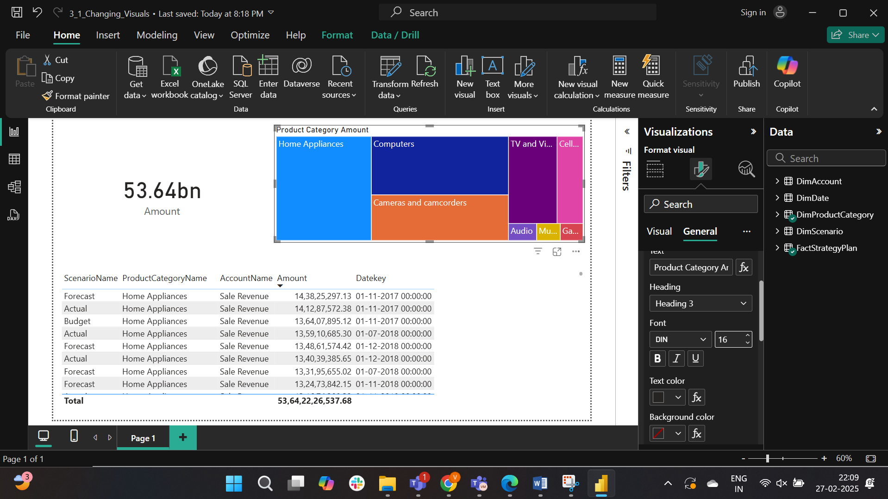

The card type is changed and scenarioname is added.

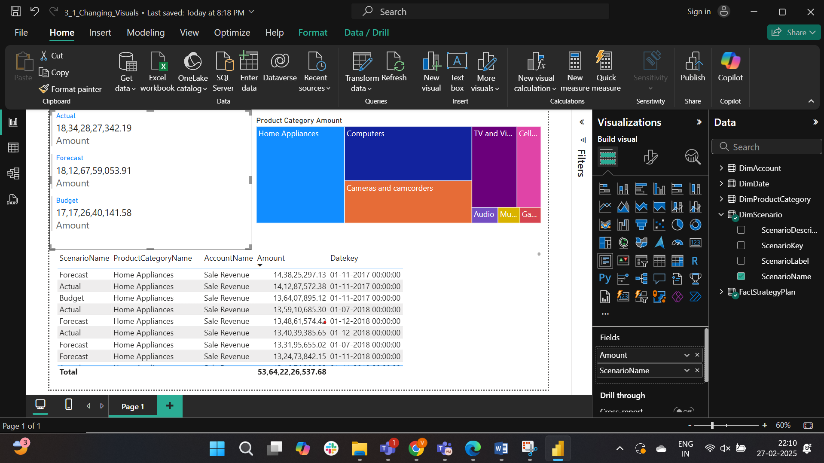

The total forecasted sales amount is $18.127B

Part-2:

The table is changed to Matrix

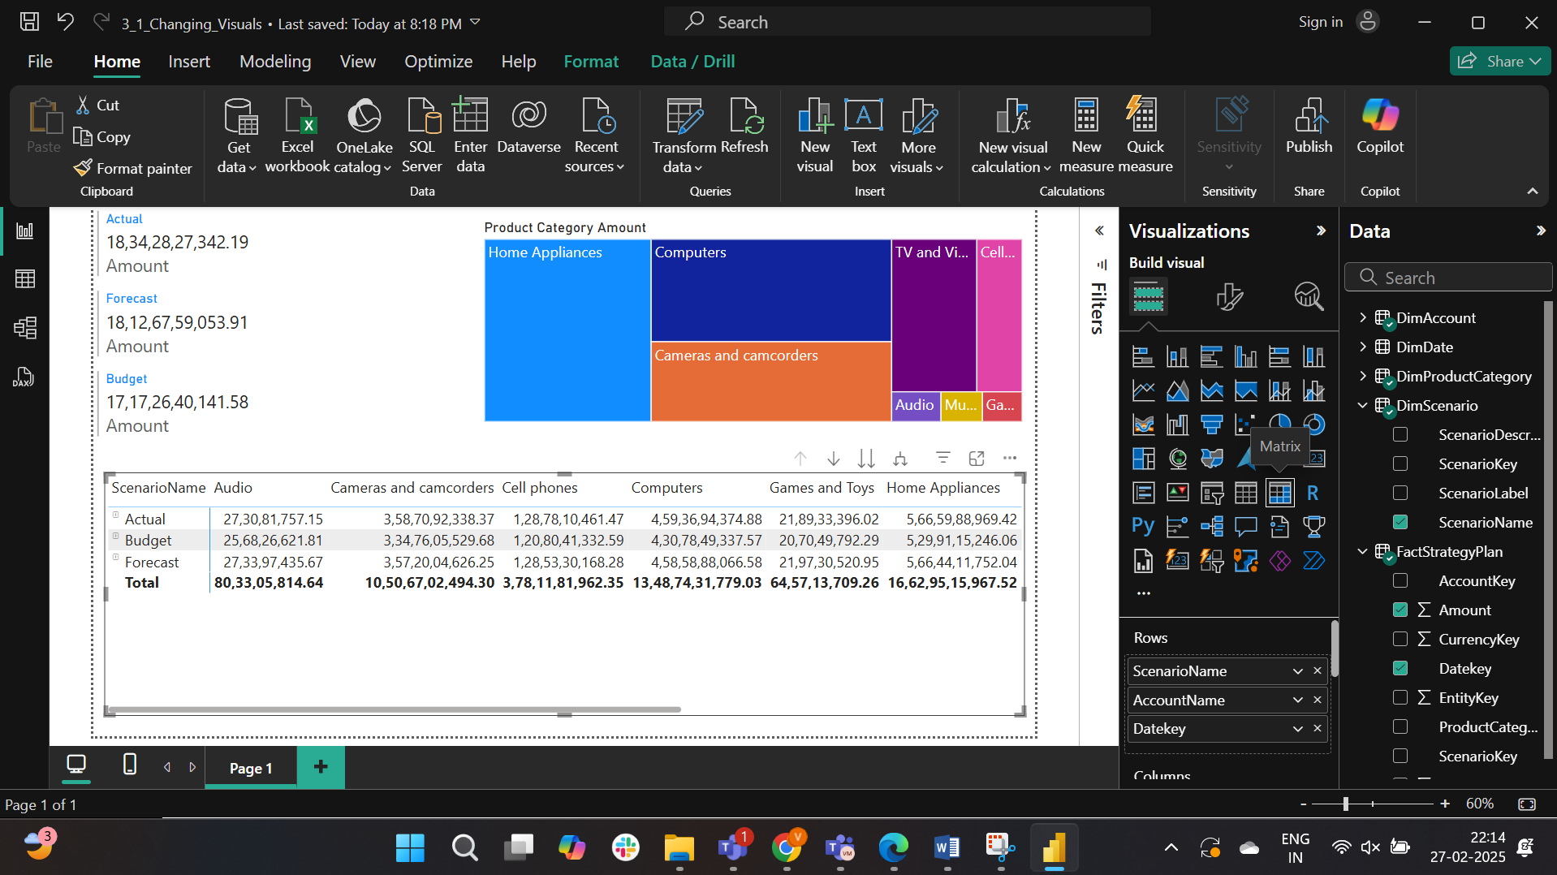

Text size of column header is changed to 18

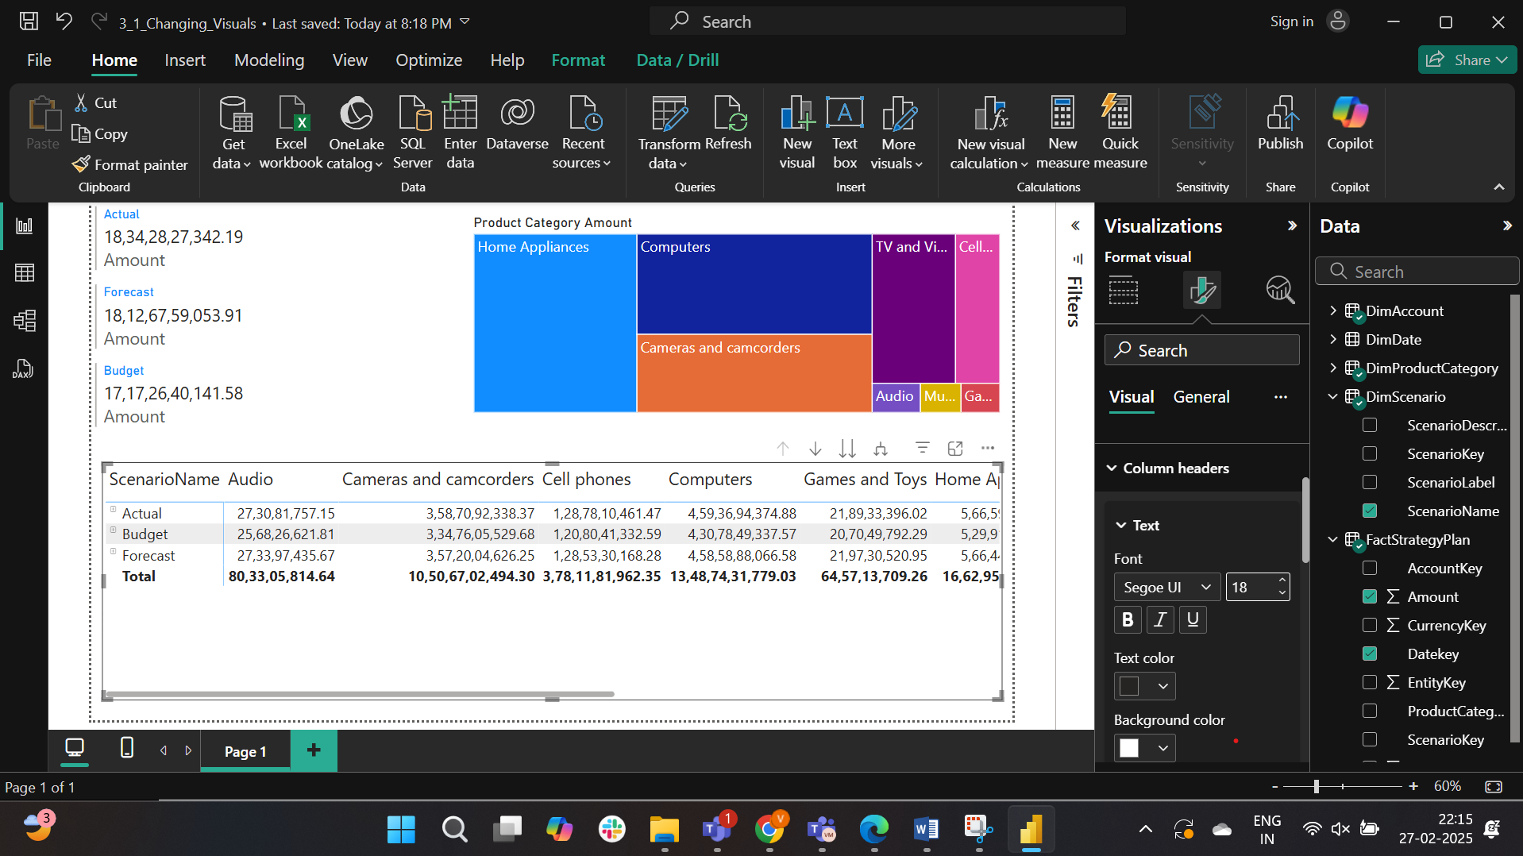

Text size of row header is changed to 18

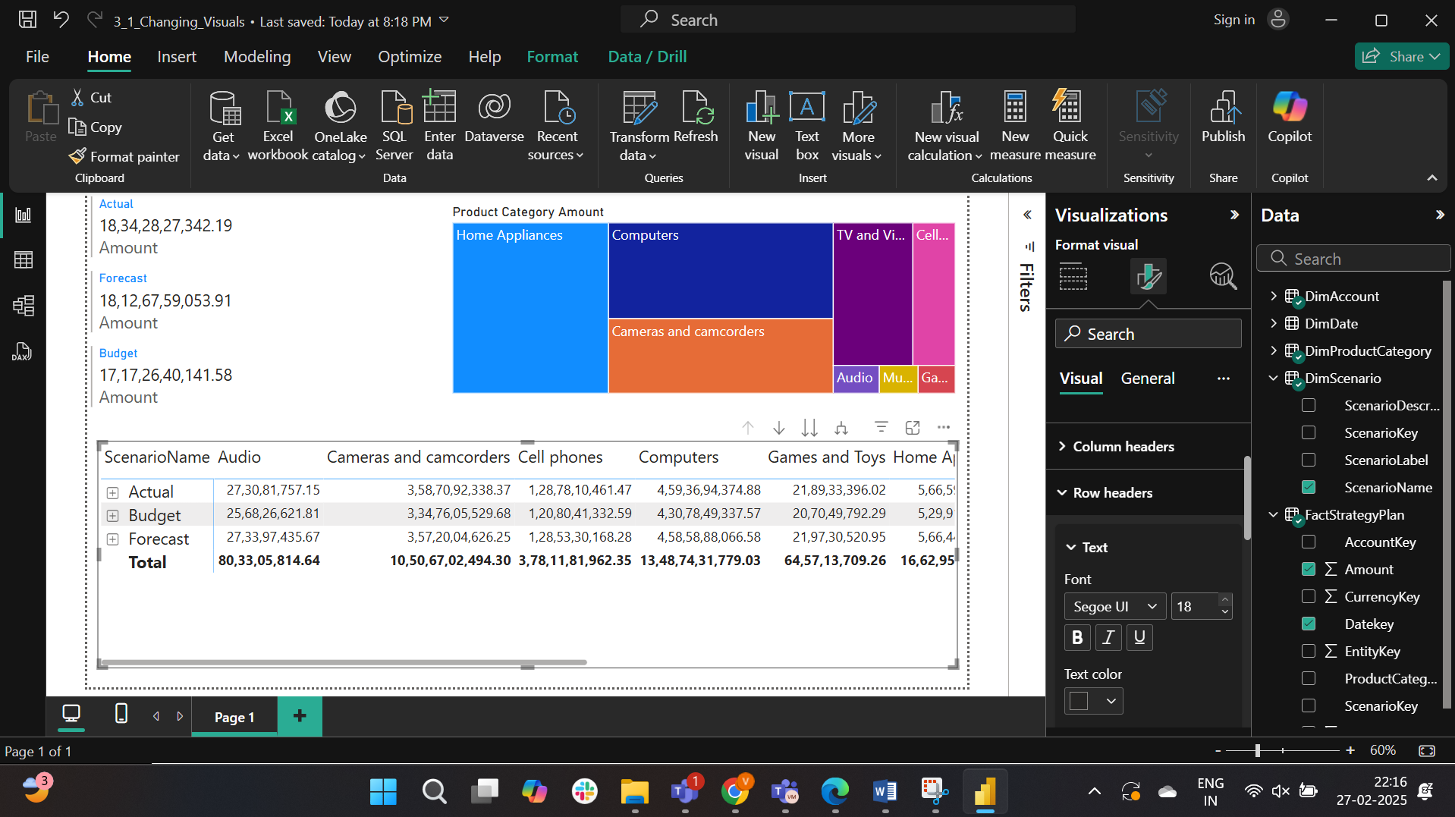

The values size is also changed to 18

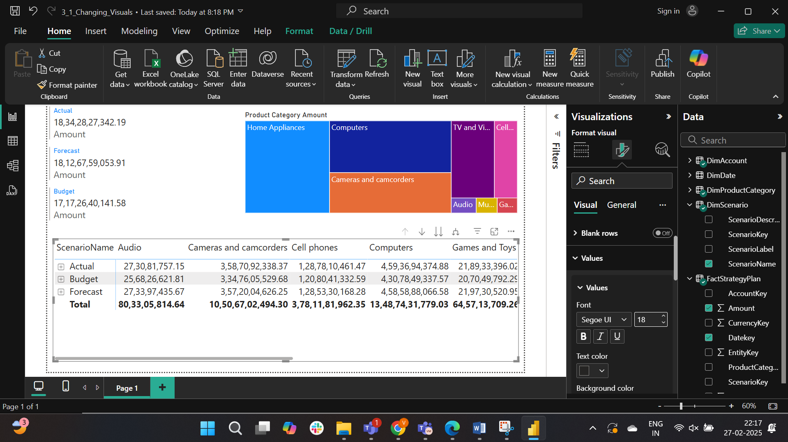

The budgeted amount for cellphones is 1208041332.59

Part-3:

The .pbix file is loaded.

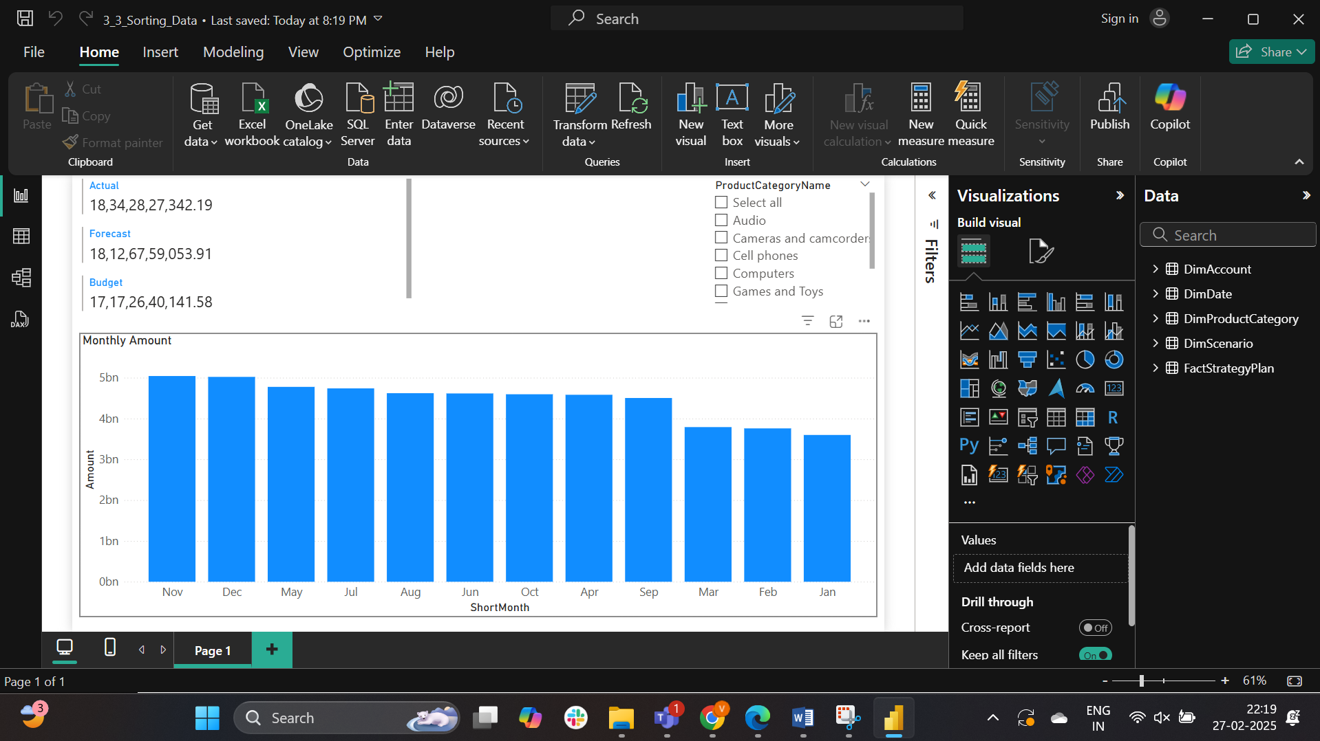

The shortmonth in DimDate is ordered by monthNumber

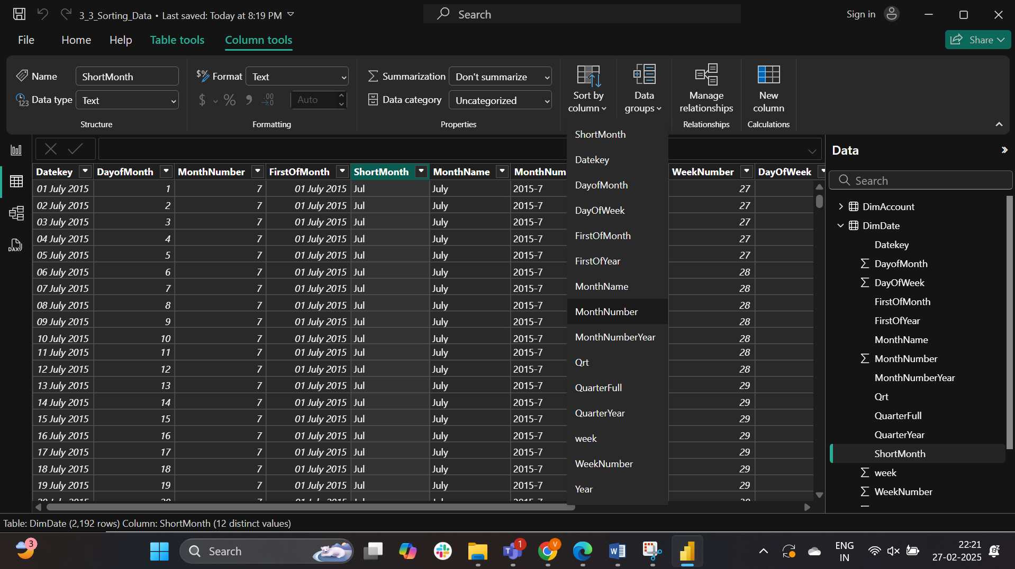

The columns are sorted based on the months and in ascending order.

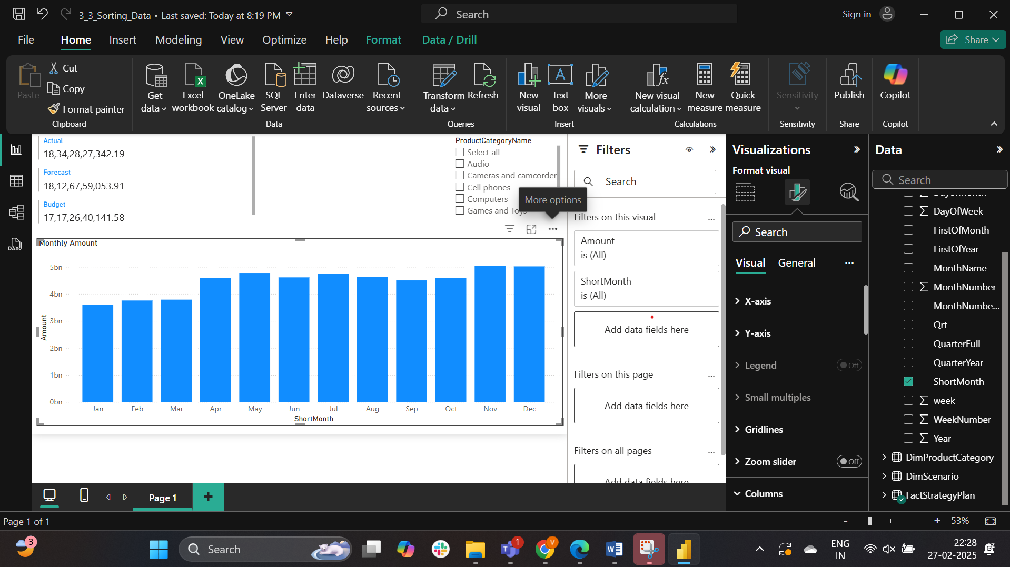

Answer there is an upward trend.

Part-4:

The slicer header is turned off

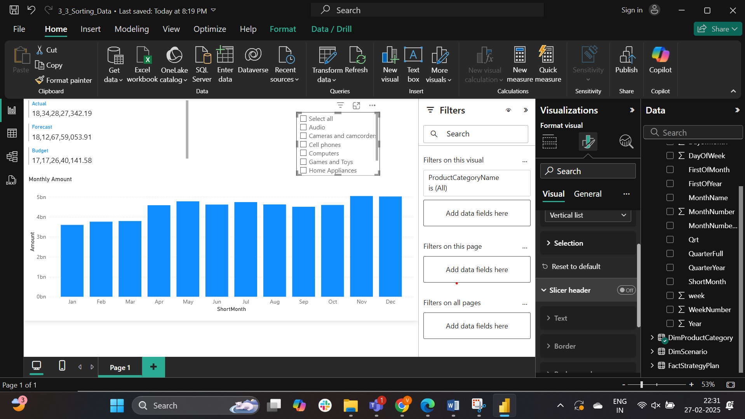

The slicer is formatted into a dropdownbox

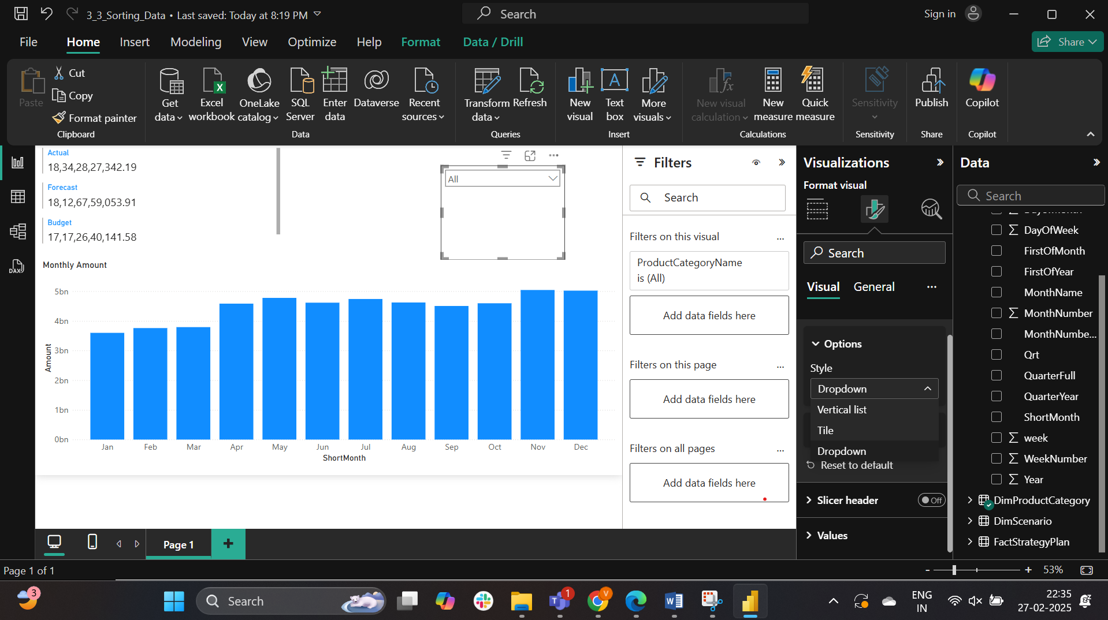

The style option has all of the above options (Vertical list, Title, Dropdown)

Part-5:

The Sunset theme is applied.

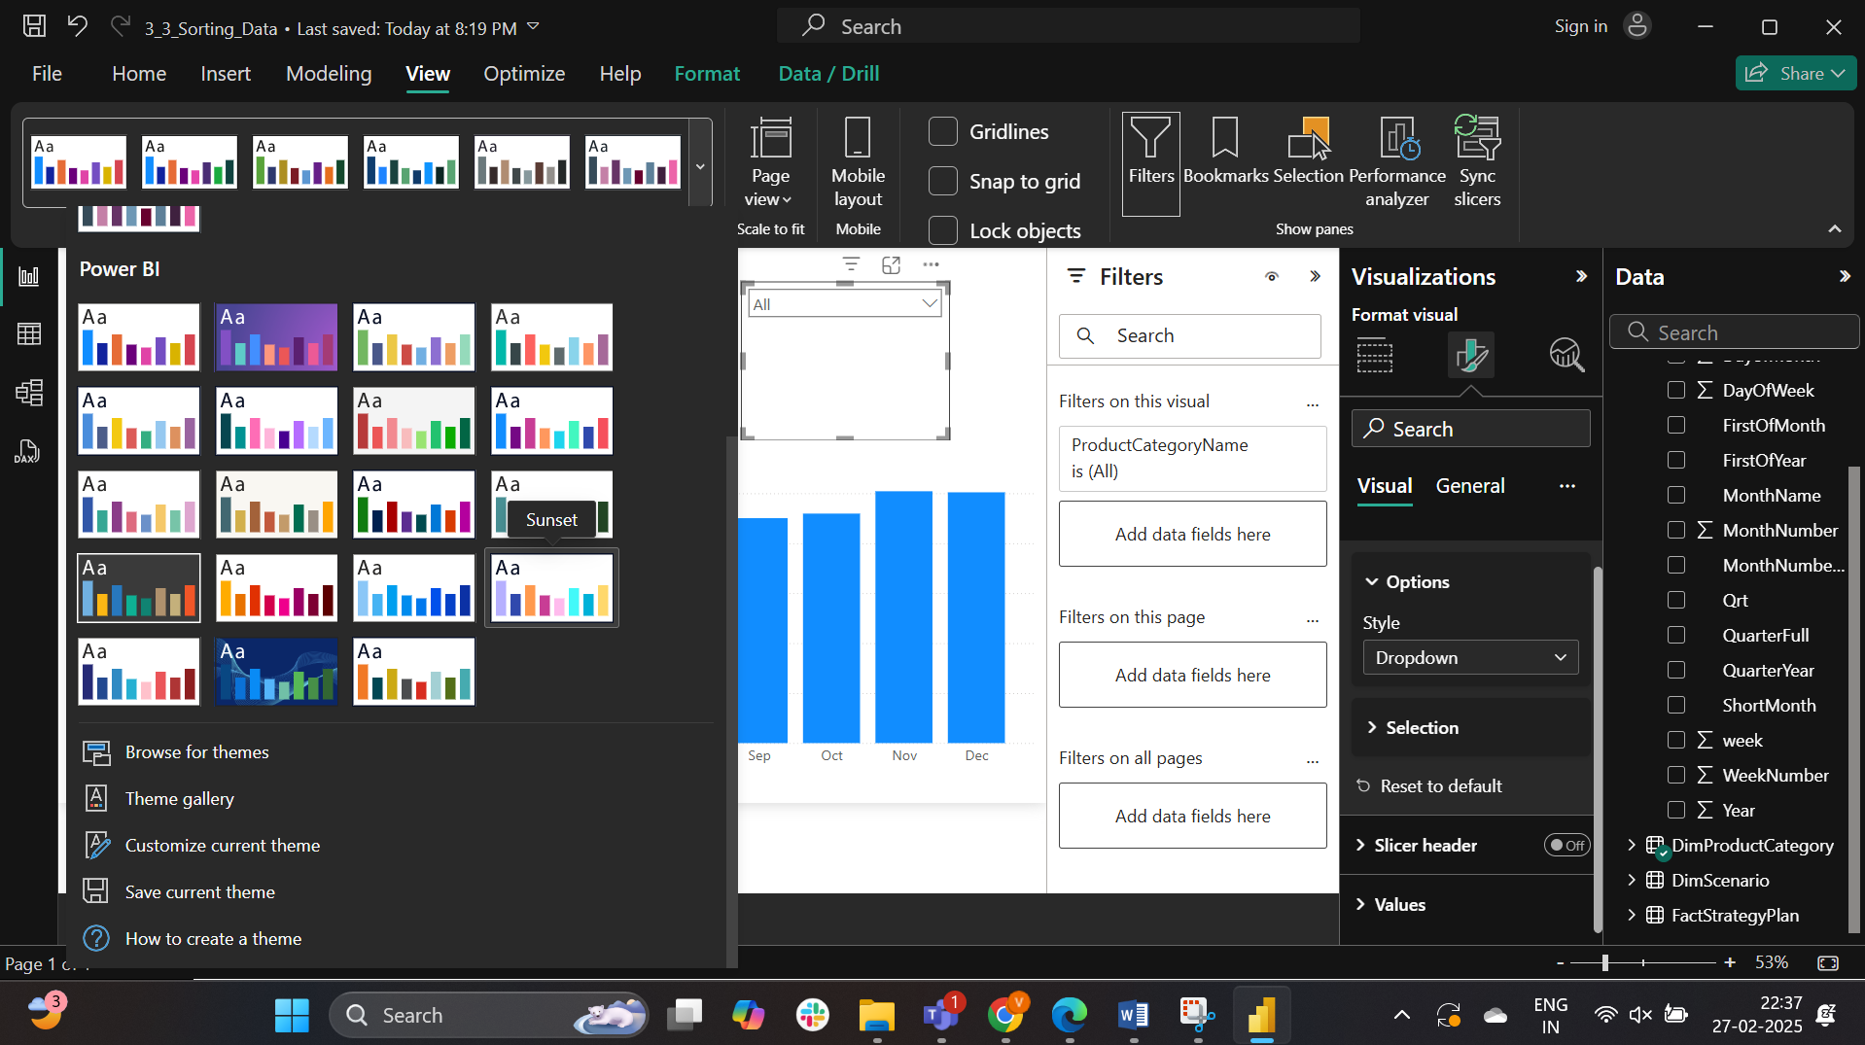

After applying the Sunset Theme.

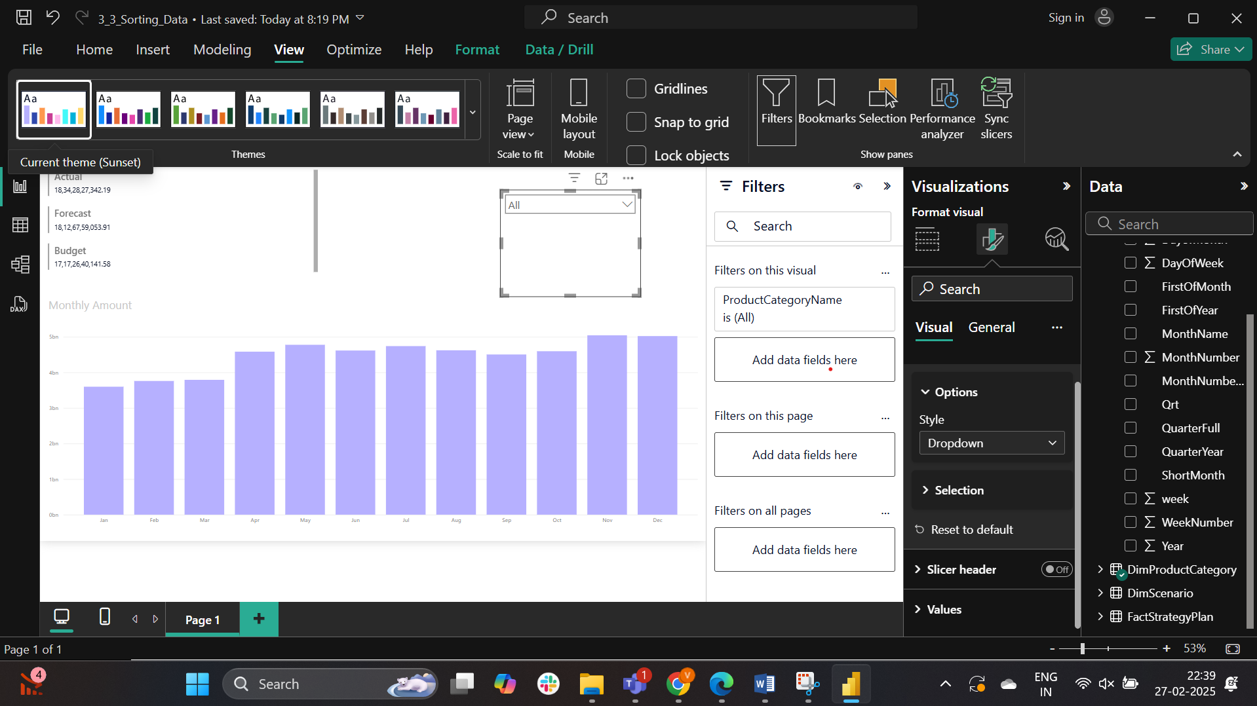

Both the dropdown box and multi-row card are adjusted to same height

Th height of dropdownbox

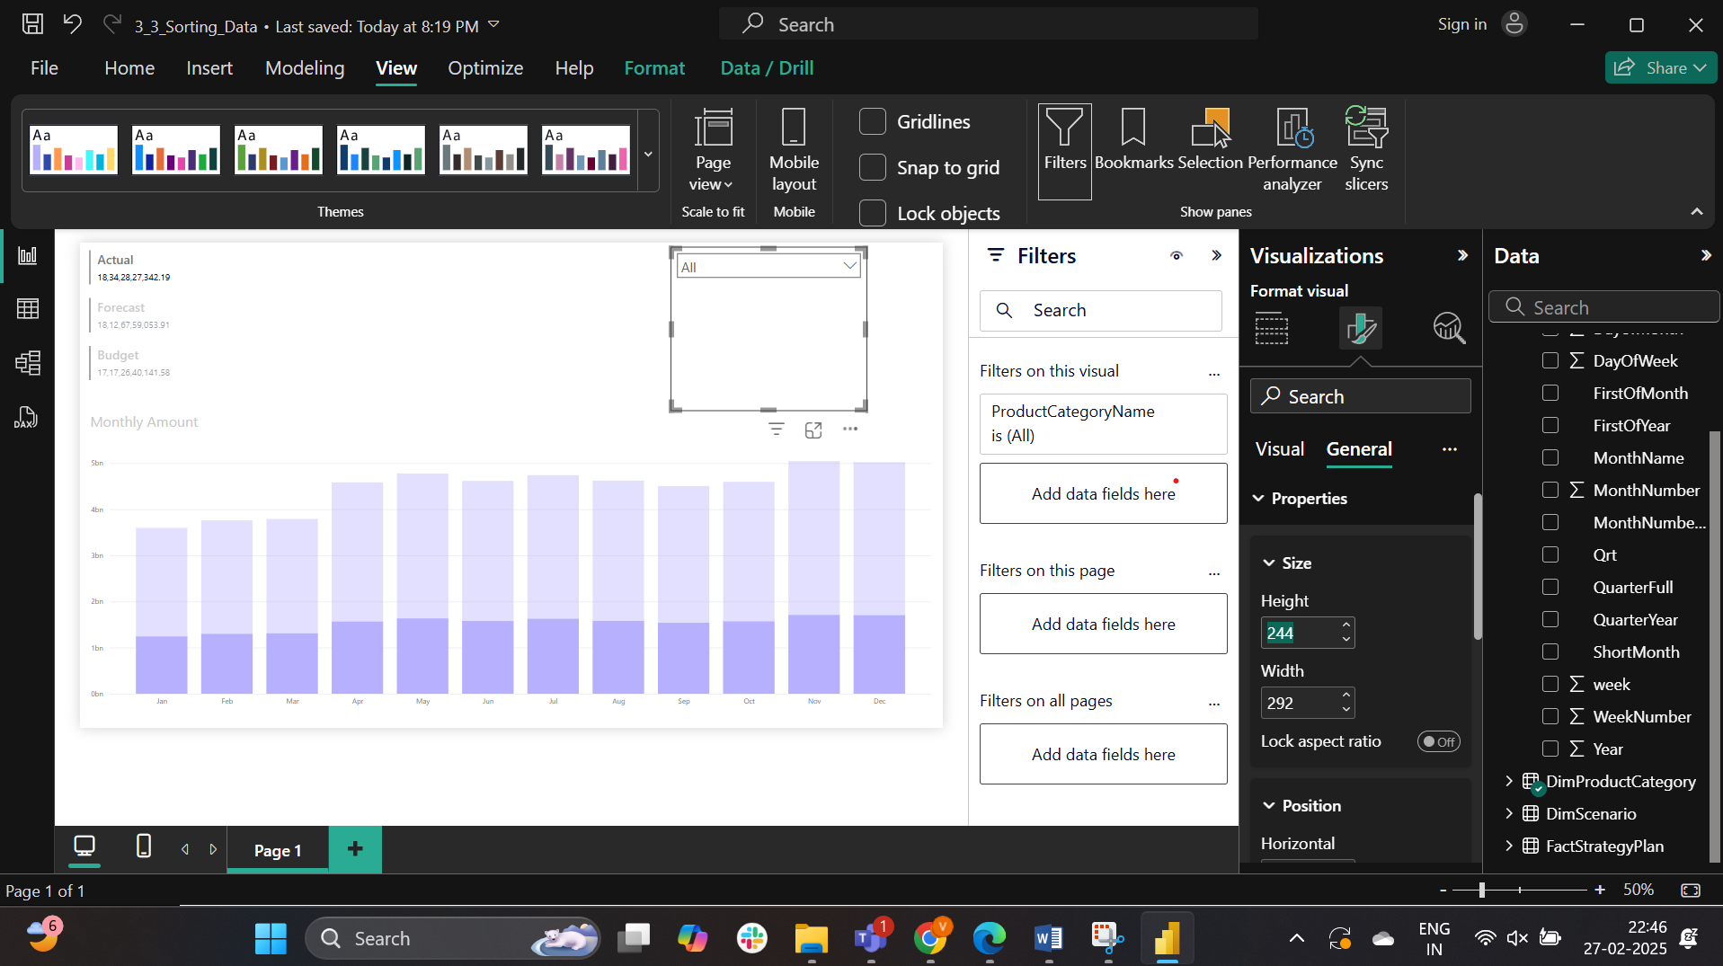

The height of Multi-row card

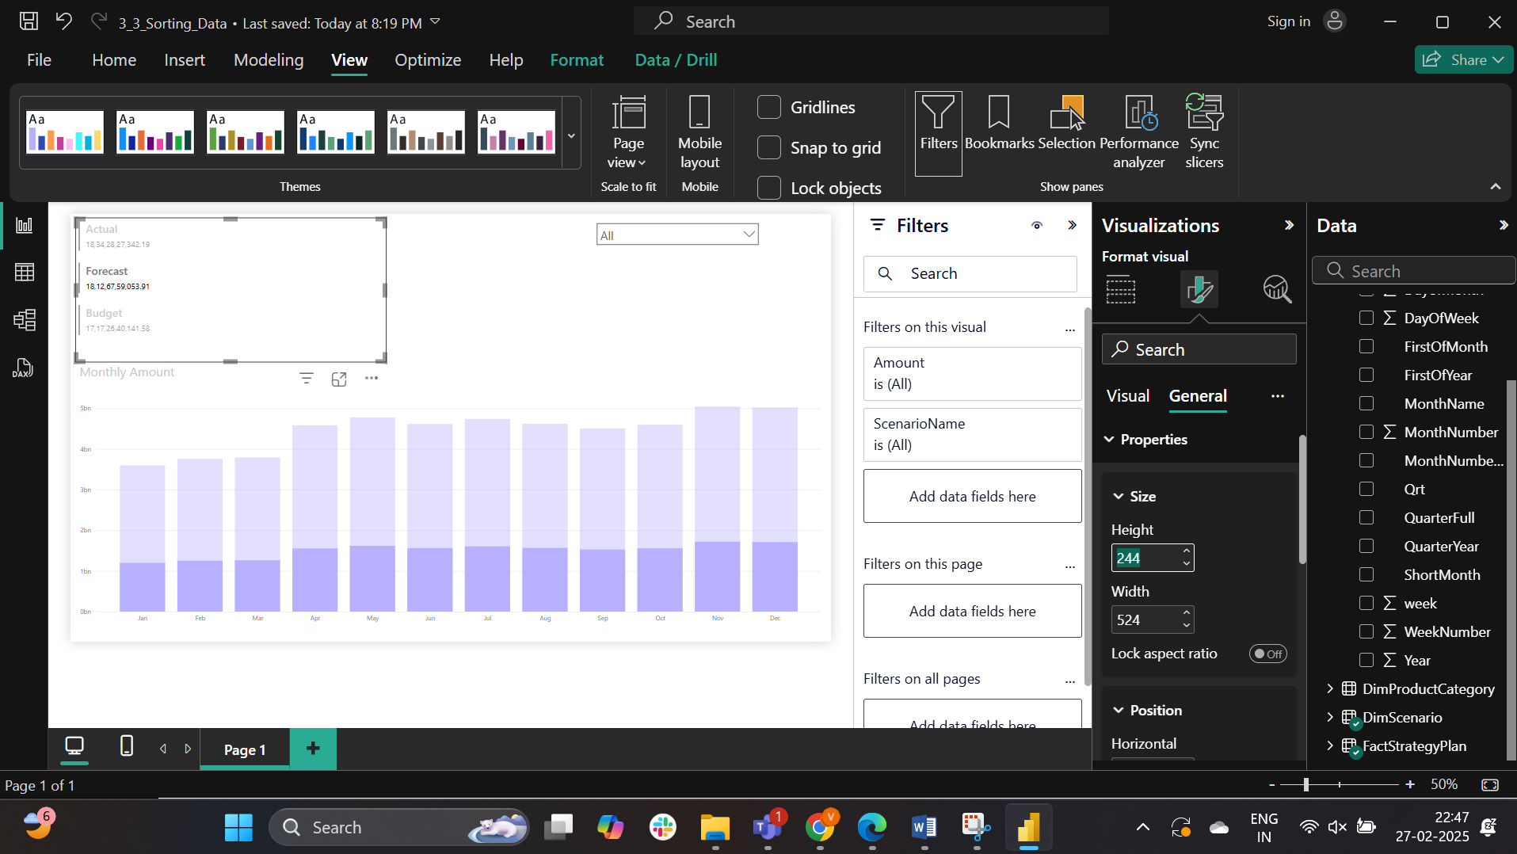

Answer: Horizontal

Lab4

Part-1:

The file has been opened.

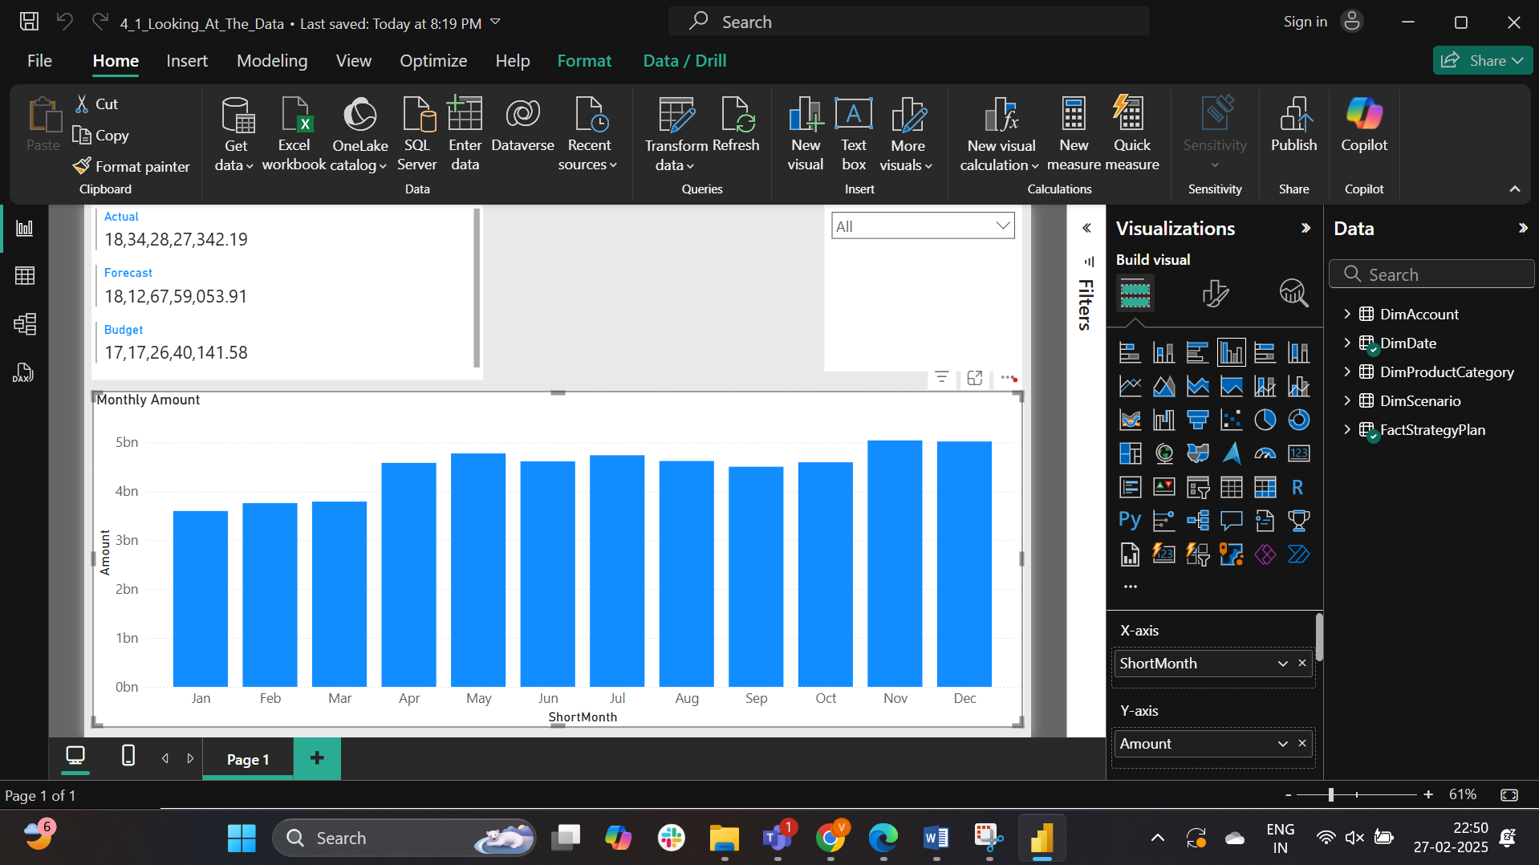

To display the underlying data the visual is being exported.

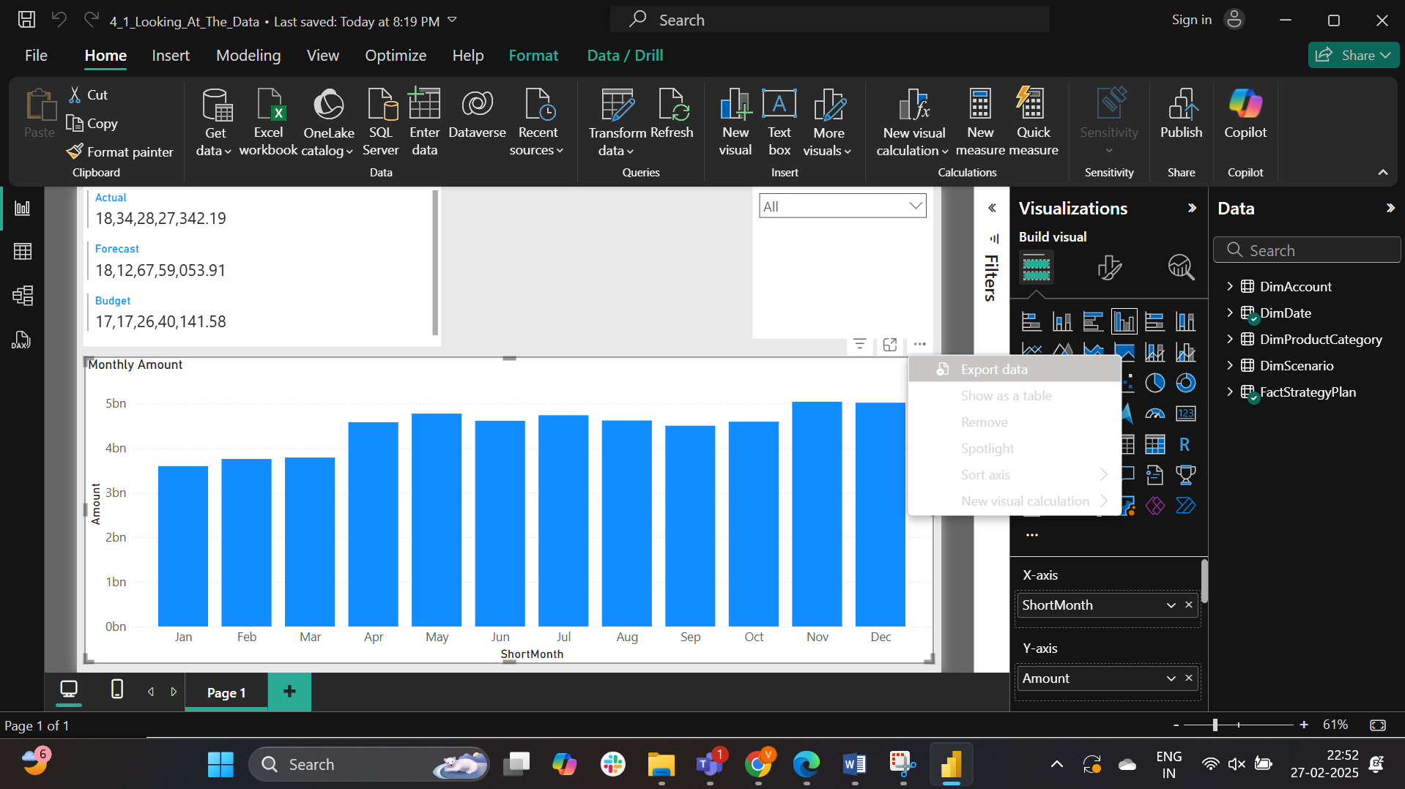

The csv file is opene using the notepad

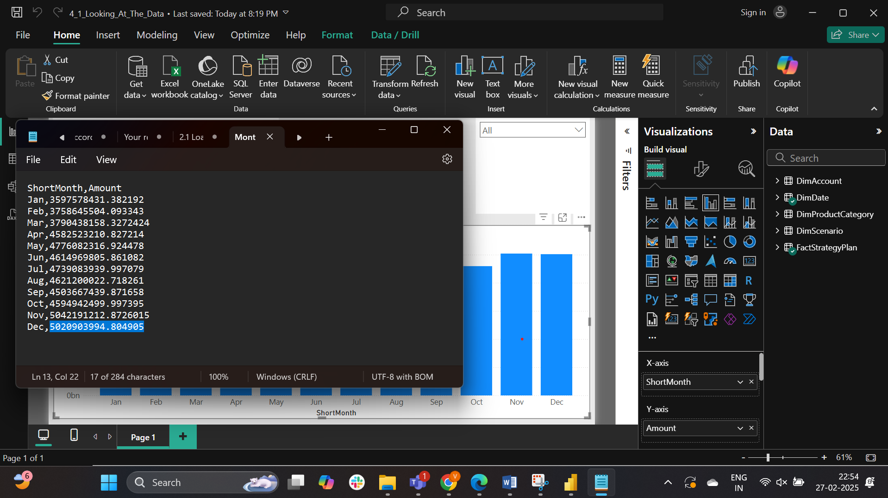

The last character in the csv file is ‘5’

Part-2:

The hierarchy is created.

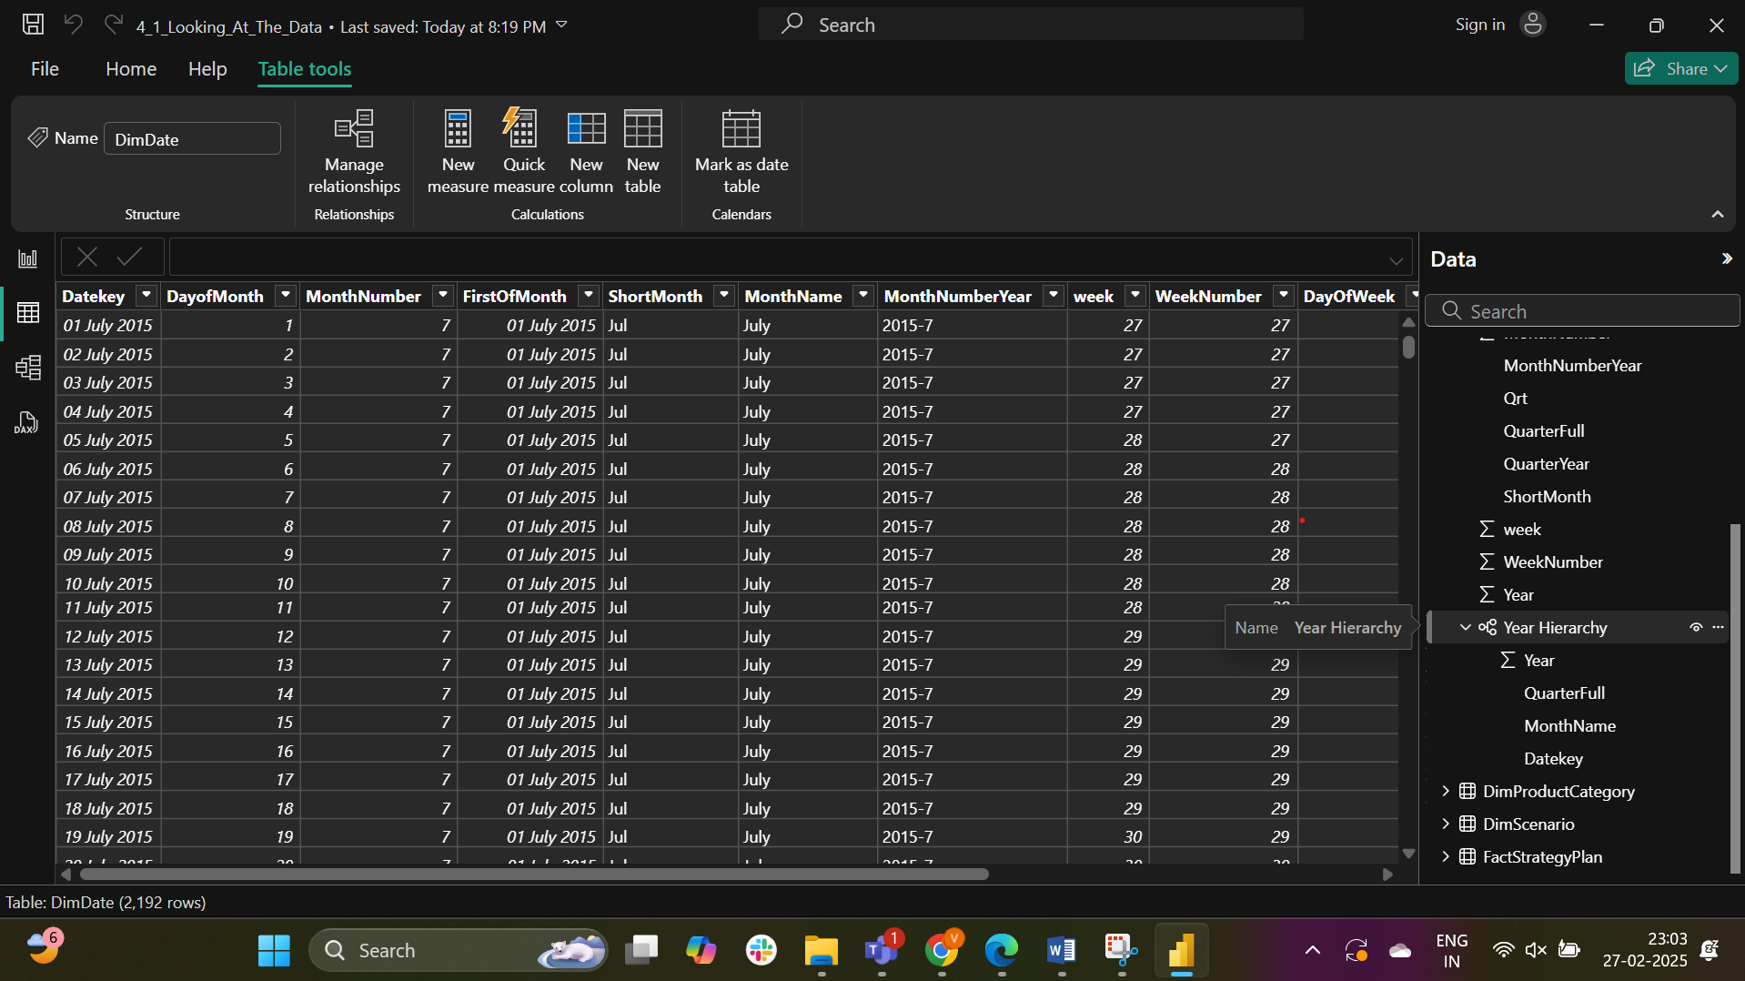

The hierarchy is renamed as Date Hierarchy

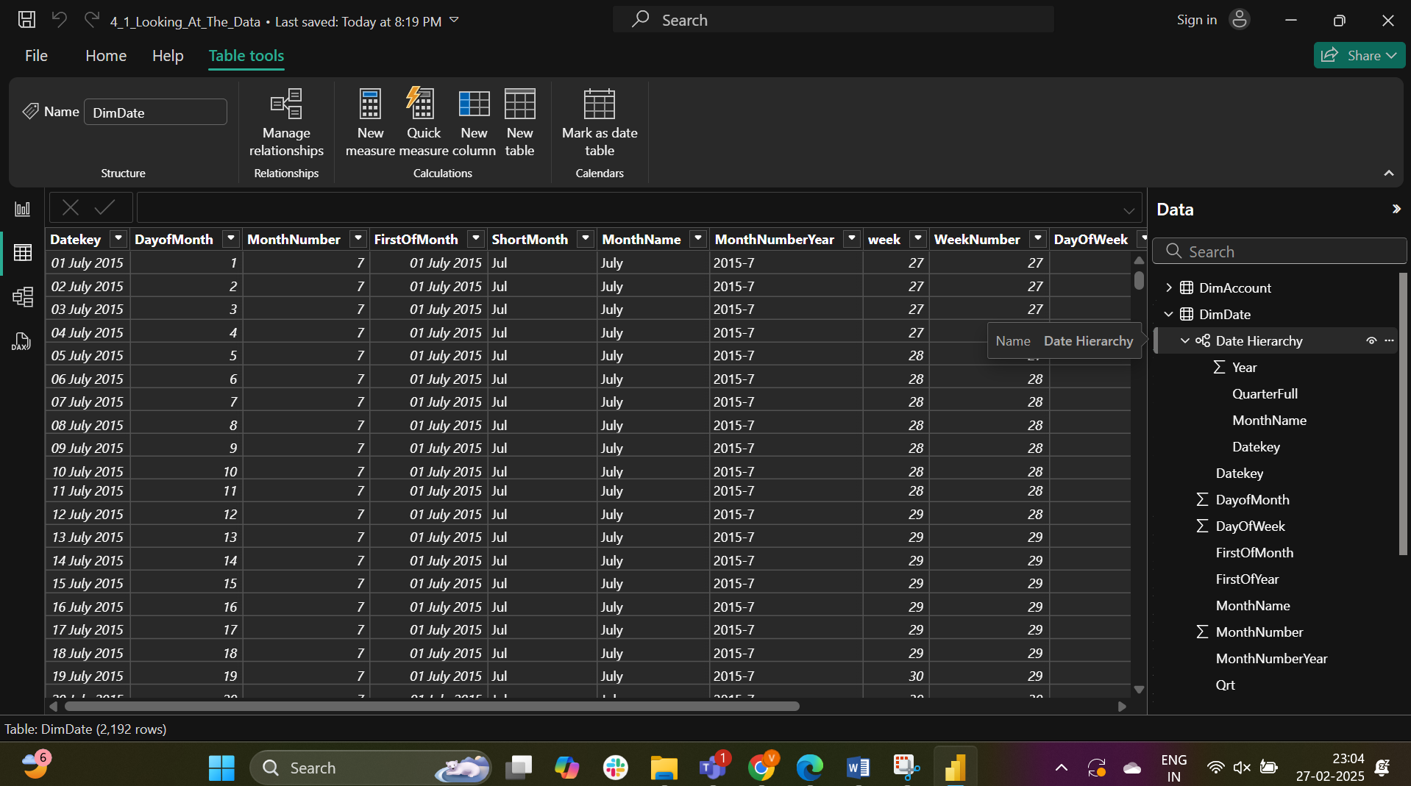

In the report view the ShortMonth Column is replaced by Date Heirarchy

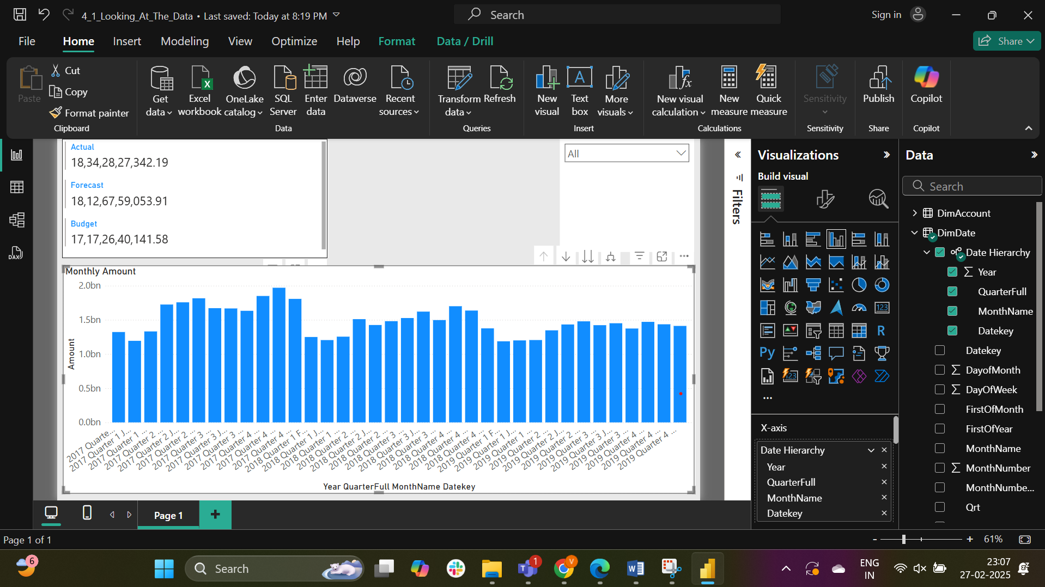

The drill mode is enabled.

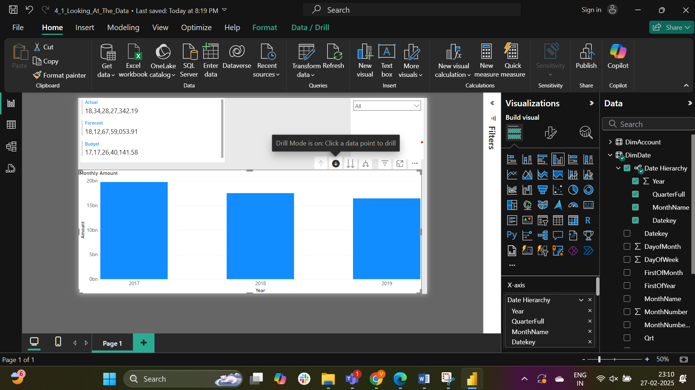

Q4 of 2017

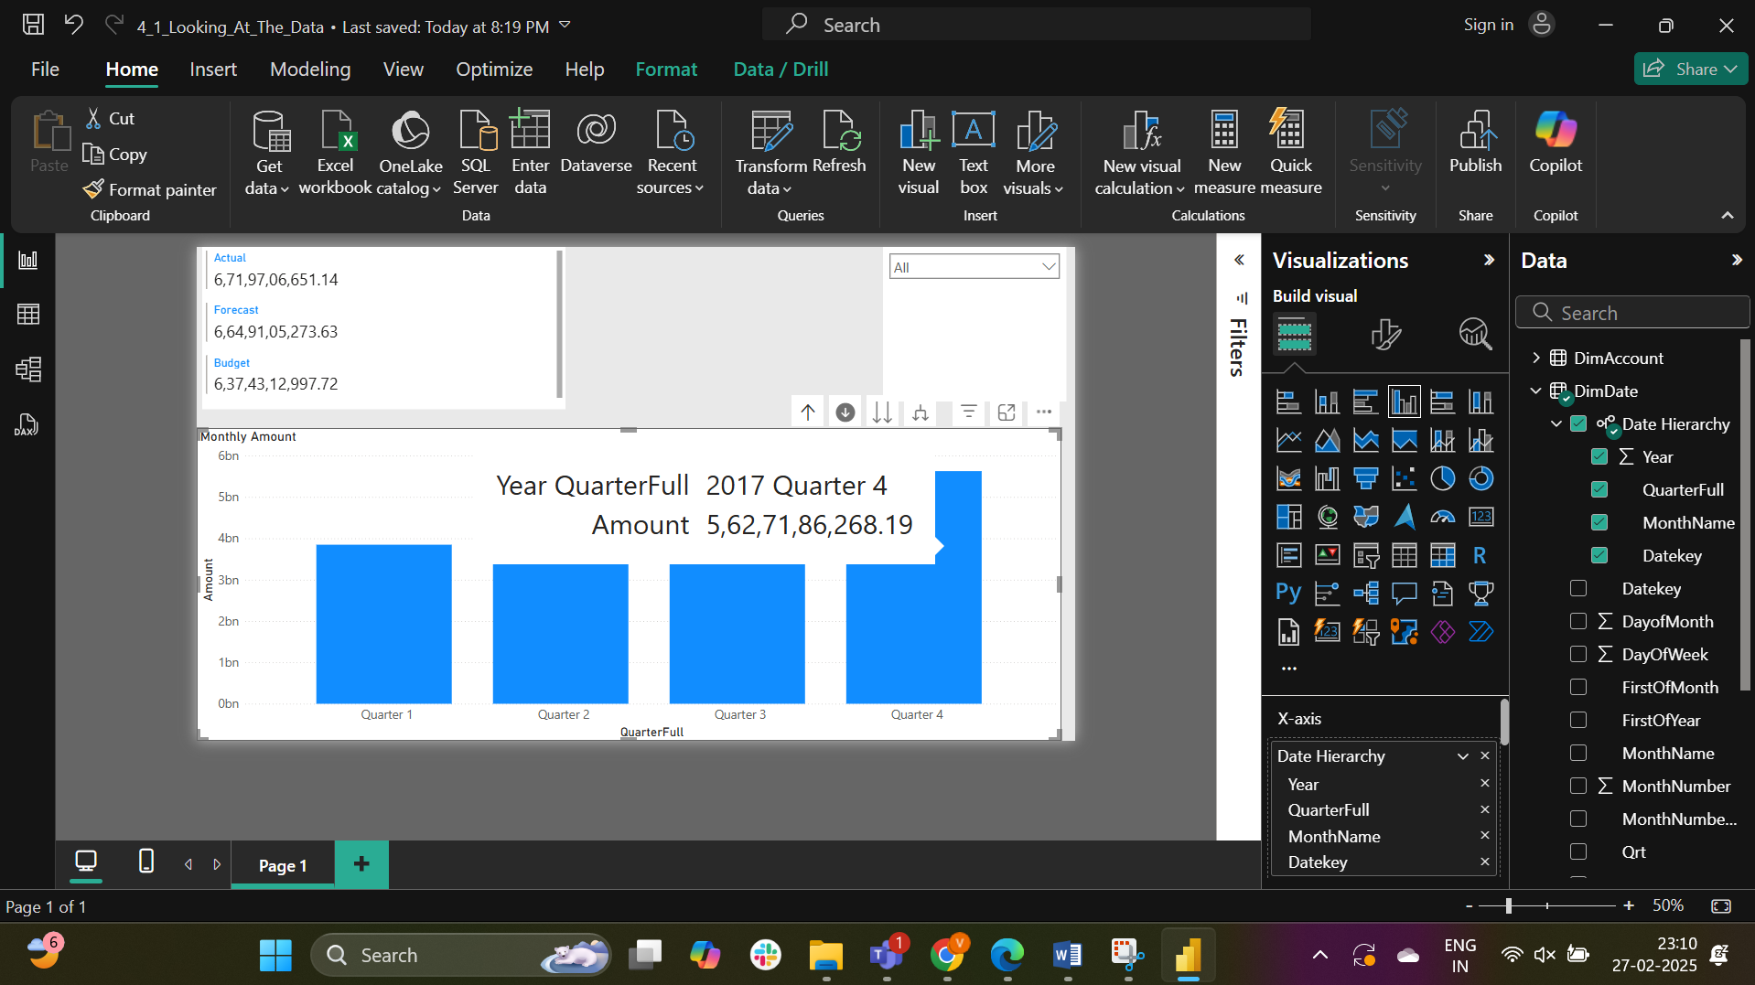

Answer: Y2017 Q4

Part-3:

The.pbix file is loaded

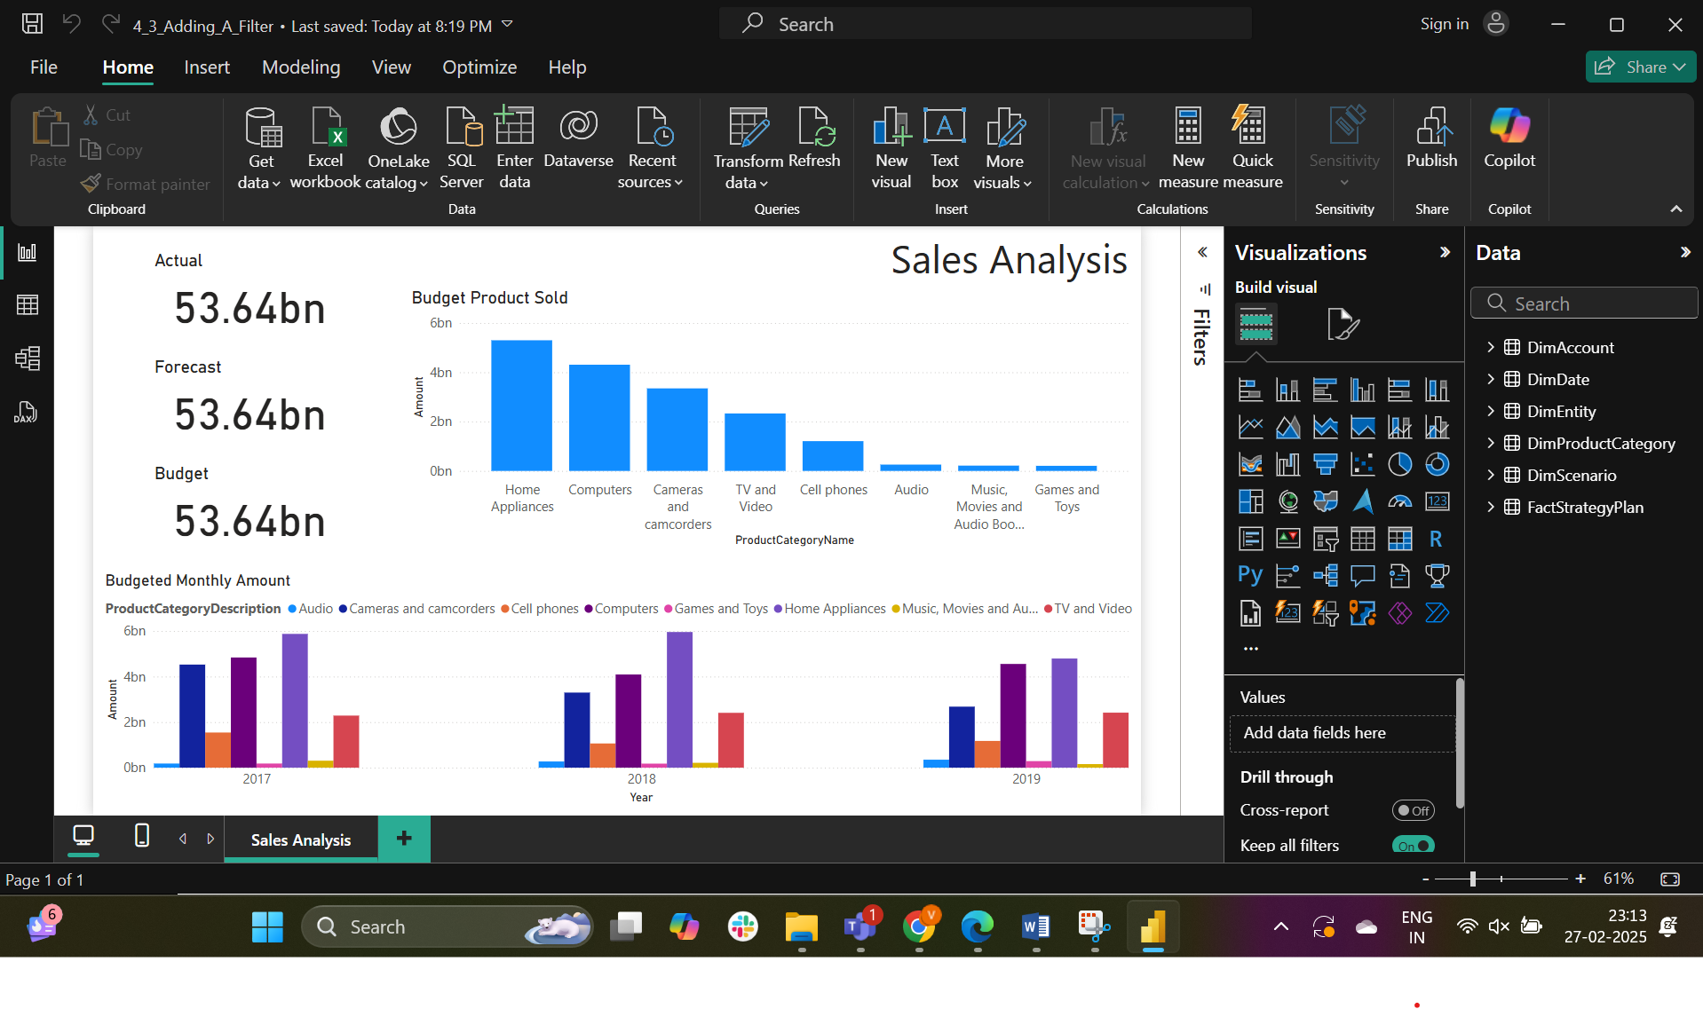

The Scenario Name is added as a filter to the actual card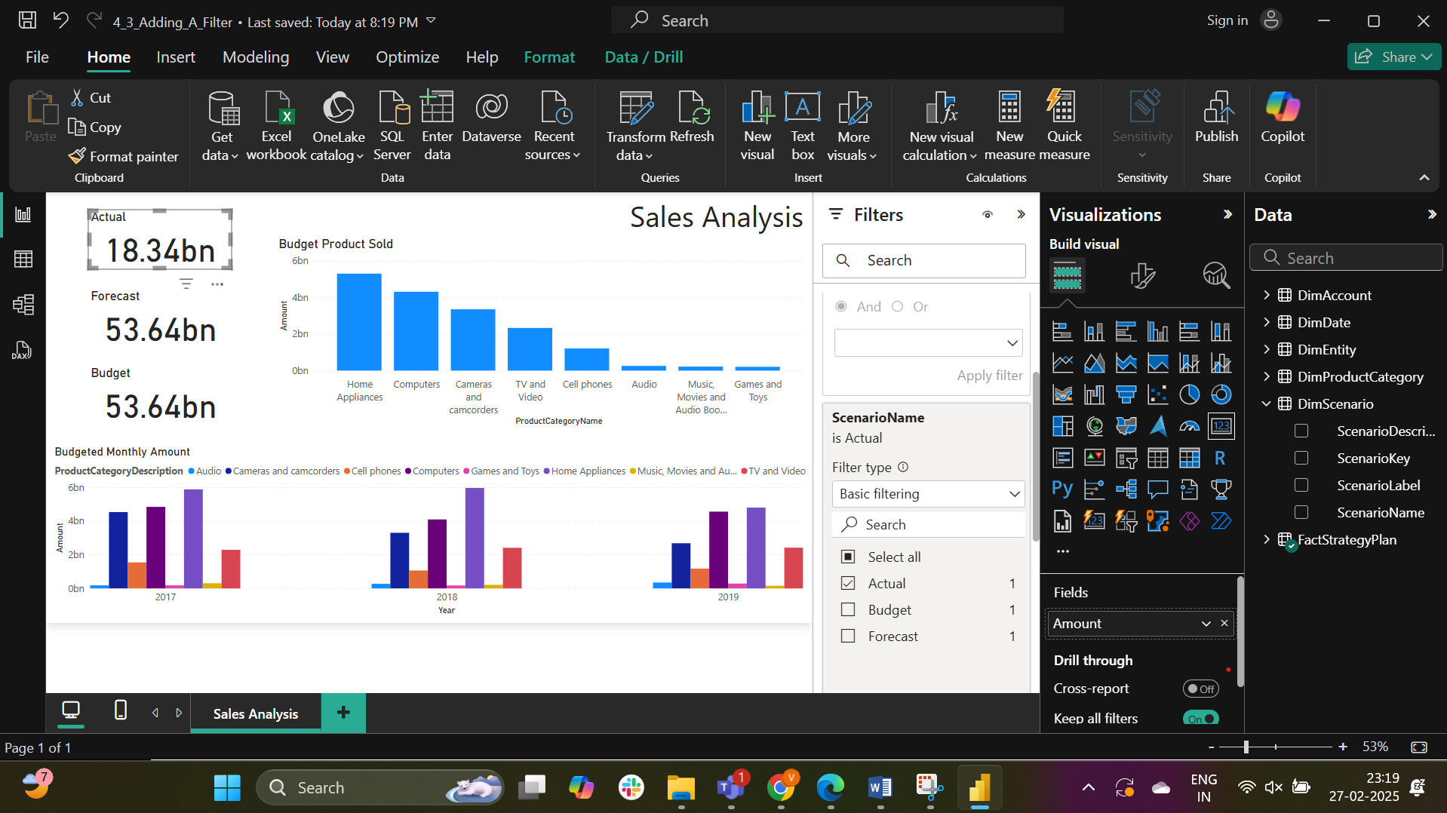

The Scenario Name is added as a filter to the Forecast.

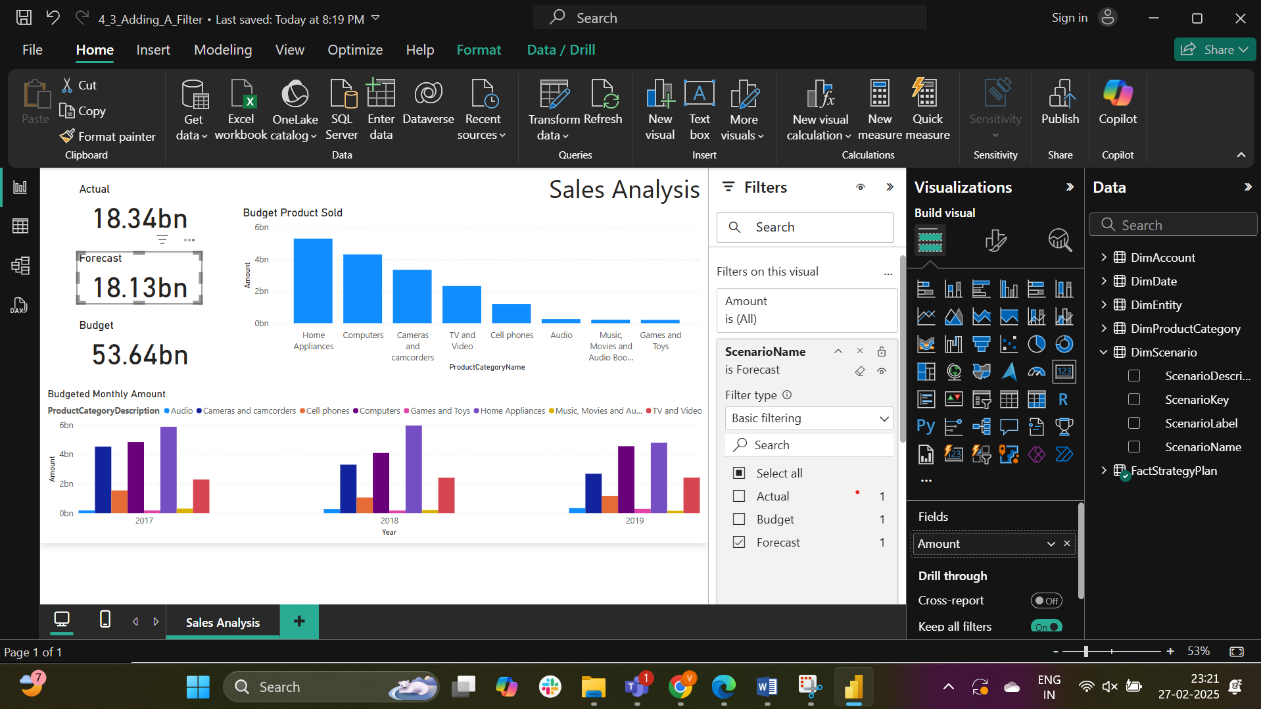

The Scenario Name is added as a filter to the Budget.

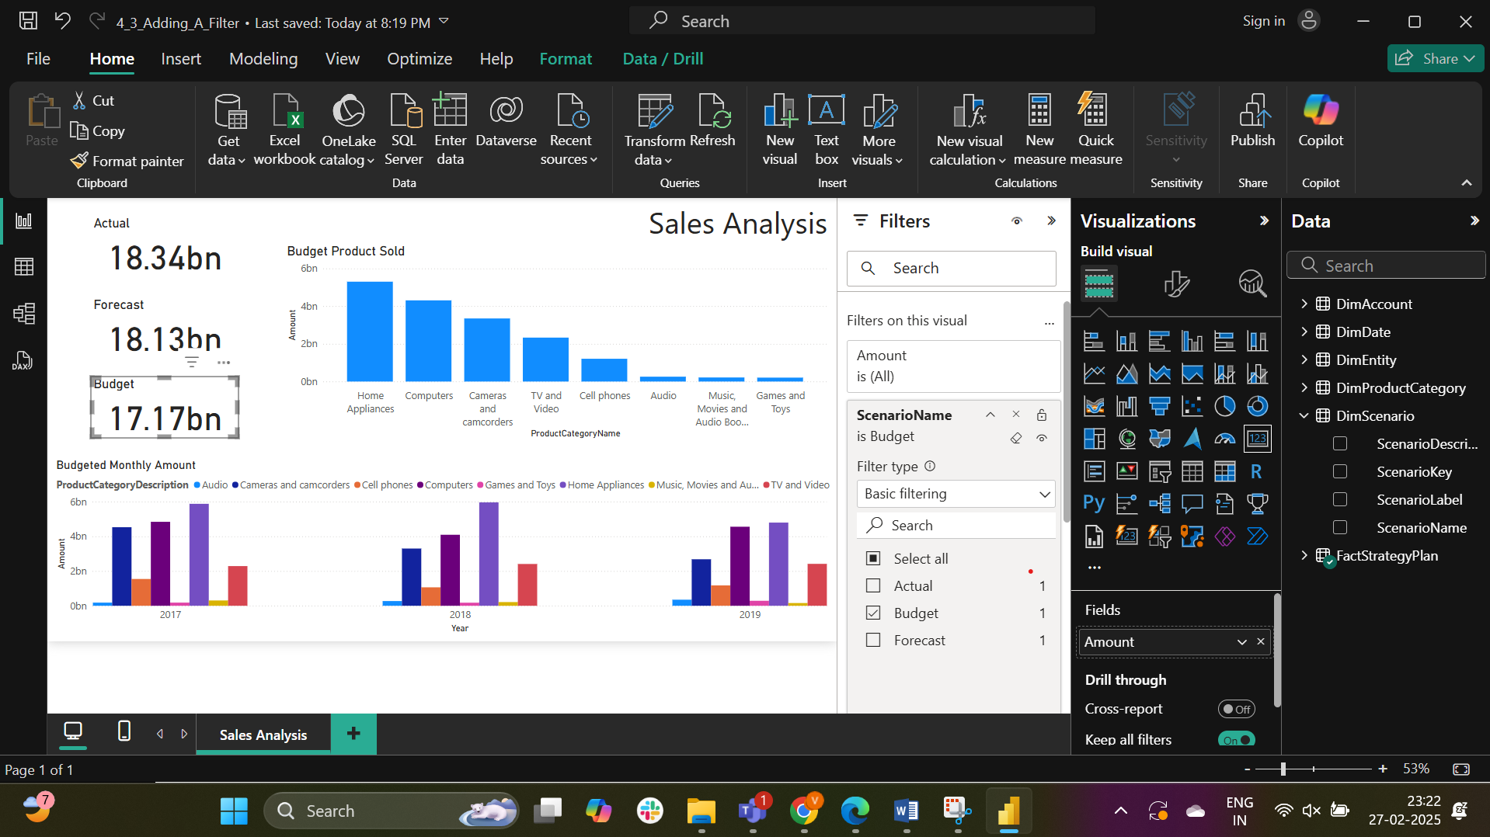

The total forecasted amount is 18.13bn

Part-4:

The interactions are turned off

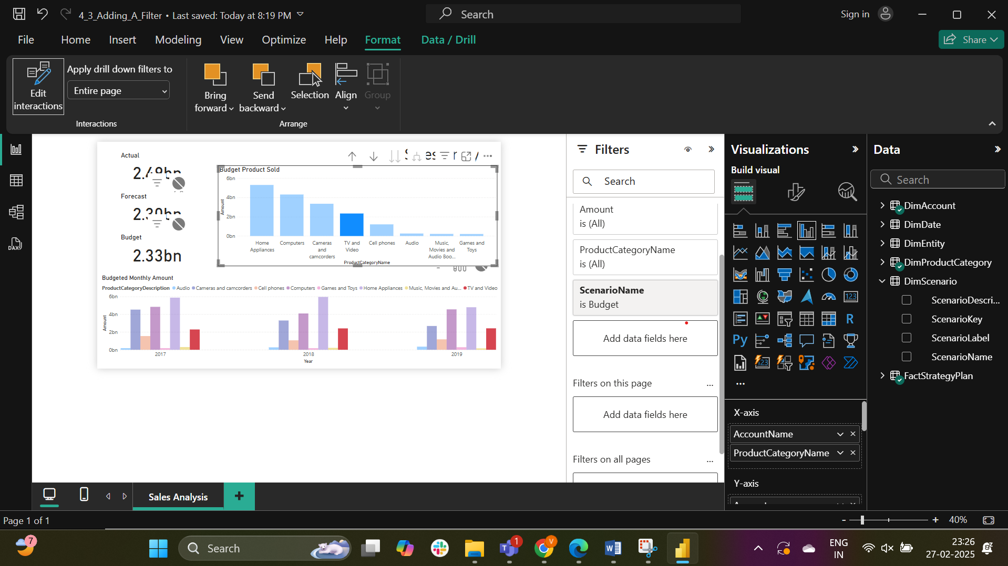

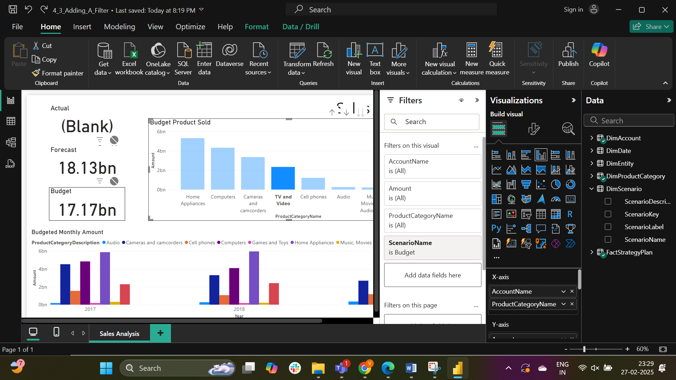

Answer: The value on the budget card is 17.17bn

Part-5:

The Budgeted Monthly Amount chart is being removed.

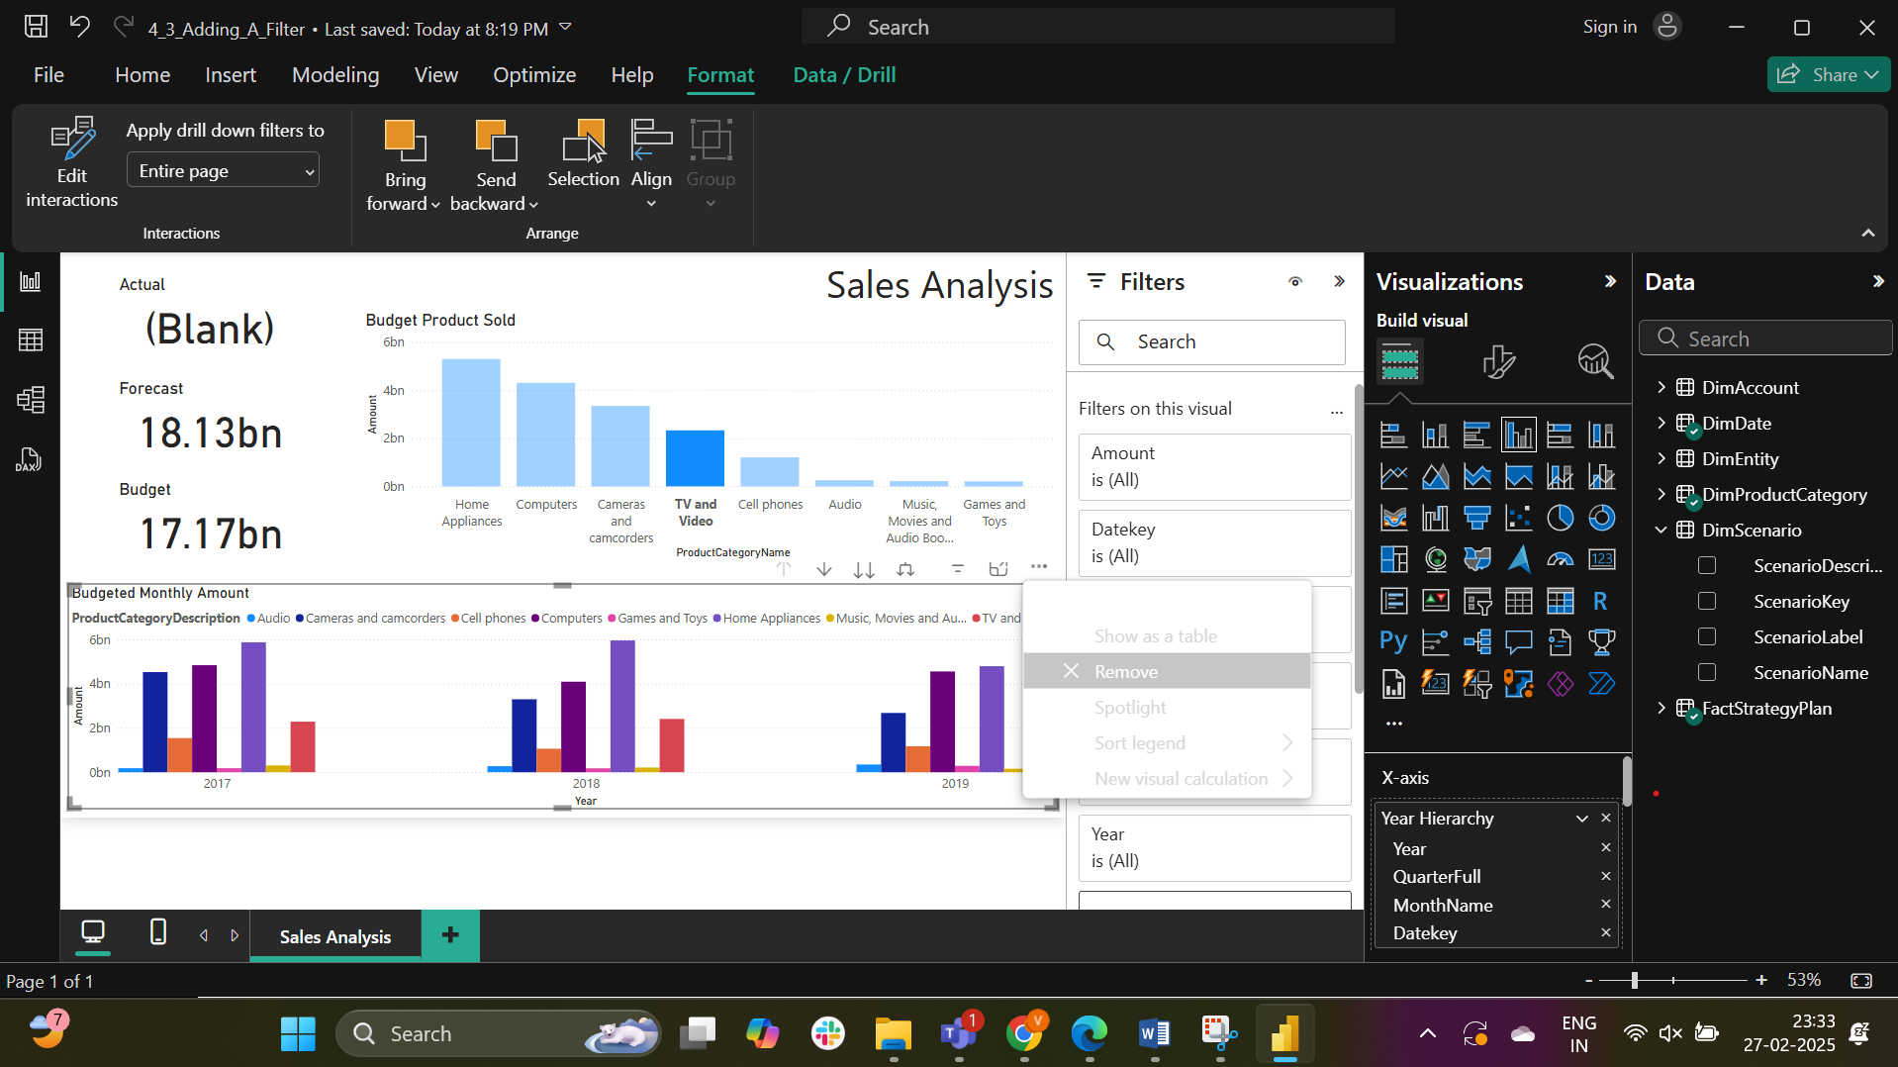

A new Clustered bar chart is added

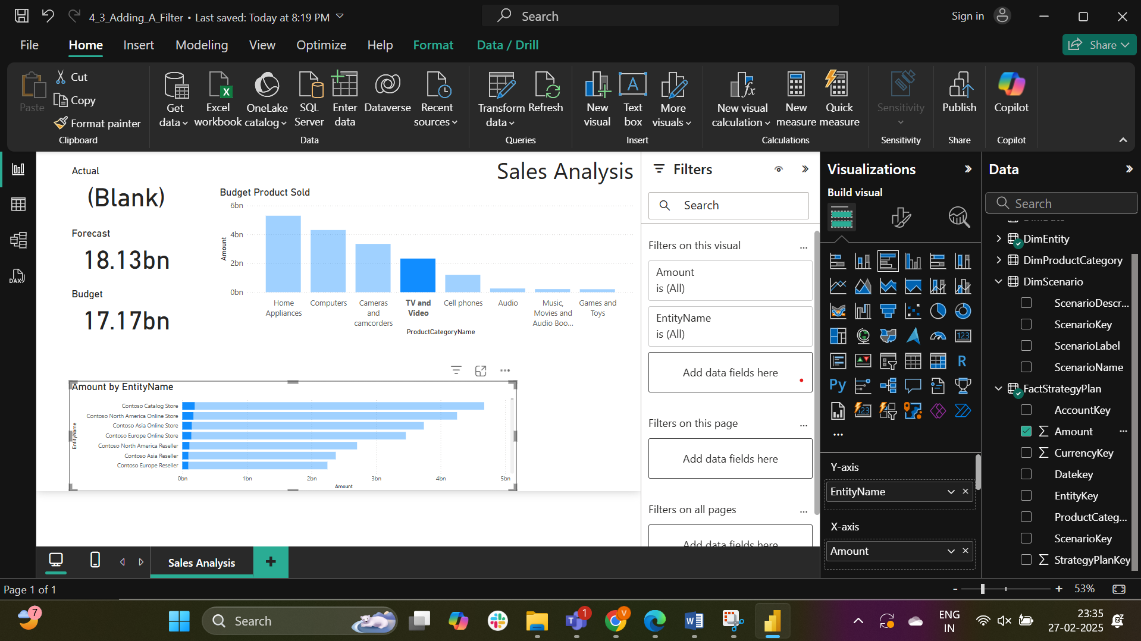

The topN filtering is being added to the EntityName

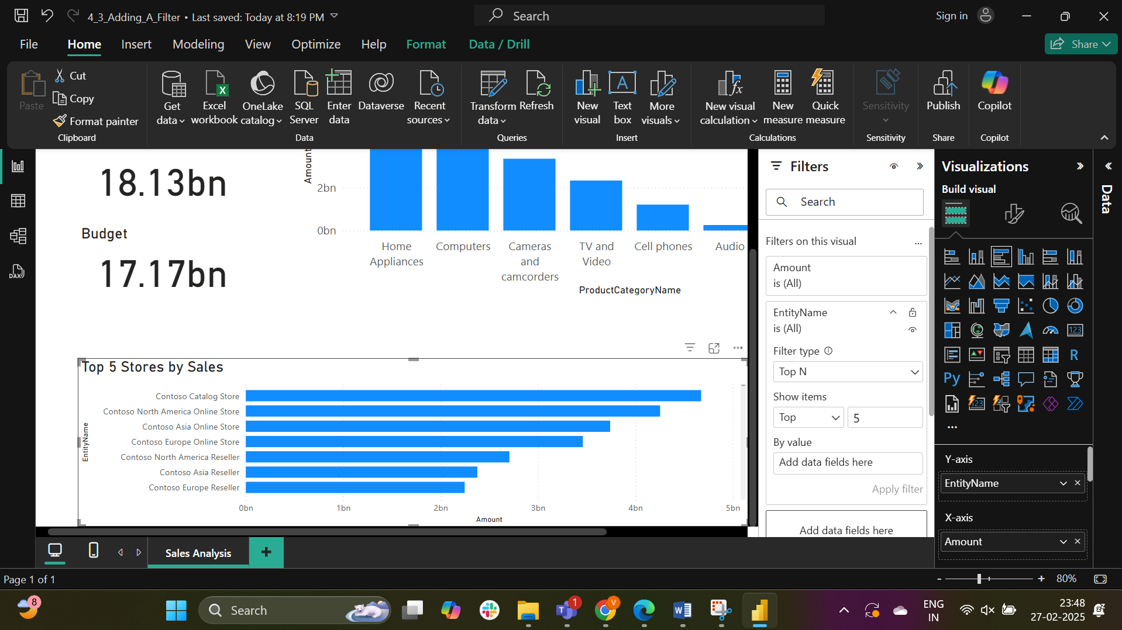

The answer is Costco North America Reseller